Major Causes of cerebellar disease
- Vascular
  - Stroke, TIA
- Infection
  - Bacterial meningitis/abscess, TB
  - Viral HSV (acute) or HIV (Chronic)
- Trauma
- Autoimmune
  - MS
- Metabolic/Nutritional
  - Wilson’s disease, cerebral oedema secondary to hypoxia
  - Thiamine Wernickes (ataxia, ophthalmoplegia, confusion)
  - Vitamin E deficiency
- Neoplasia
  - Tumours, abscess, hydrocephalus
- Congenital
- Genetics
  - Friedrich’s ataxia;
    - Autosomal recessive trinucleotide repeat disorder characterised by GAA repeat in the X25 gene on chromosome 9
    - Typically presents at 10 – 15 years old
    - Gait ataxia and kyphoscoliosis are the most common presenting features
    - Neurological features: absent ankle jerkes, extensor plantars, cerebellar ataxia, optic atrophy, spinocerebellar tract degeneration
    - Can also get: HOCM, DM, High arched palate

Descending Pathways
- Venteromedial Pathways Control the trunk and axial muscles and originate in the brainstem
  - Vestibulospinal:
    - Input from the cerebellum. Originates in the vestibular nucleus
    - Responsible for head movements in response to vestibular stimuli and postural righting reactions
  - Tectospinal:
    - Originates in the tectum (superior colliculus)
    - Receives inputs from the frontal eye fields and LGN
    - Only present in the C spine
    - Mediates reflex head movements in response to visual stimuli
  - Reticulospinal:
    - Originates from the reticular formation, with input from the red nucleus, cerebellum and cerebral cortex
      - It maintains muscle tone and controls semi-automatic movements
- Dorsolateral pathways originate in the cerebral cortex and controls voluntary, distal movements
  - Corticospinal tract
    - Originates in the precentral sulcus; responsible for distal fine movement
  - Corticonuclear tract
    - Carries UMNs for cranial nerves
  - Rubrospinal
    - From red nucleus
    - Mostly vestigial causes flexion of the upper limbs
Signs of Cerebellar Lesions
- DANISH
  - Dysdiachokinesis impaired rapidly alternating movements
  - Ataxia truncal (unable to sit upright, or problems with gait and posture) or limbs
  - Nystagmus
  - Intention tremor and past pointing
  - Slurred speech
  - Hypotonia

Related to the Cerebellum
- Von Hippel-Lindau Syndrome
  - Autosomal dominant condition predisposing to neoplasia due to an abnormality in the VHL gene on chromosome 3
  - Features; cerebellar haemangiomas, retinal haemangiomas (vitreous haemorrhage), renal cysts (premalignant), phaeochromocytoma, extra-renal cysts (epidiymal, pancreatic, hepatic)

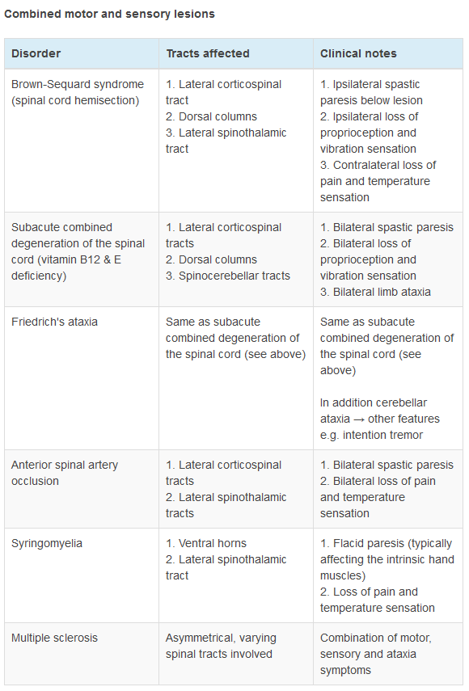

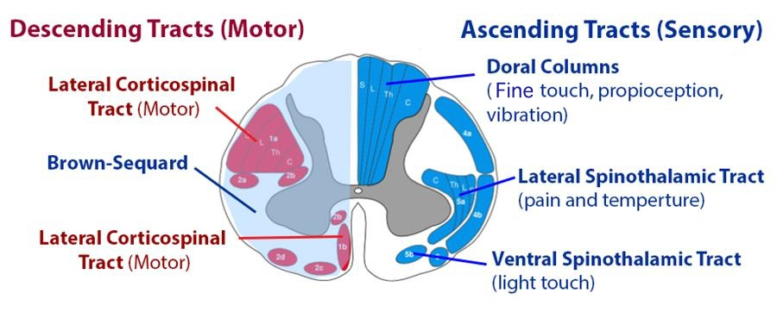
Combined: Bilateral
Neoplastic Spinal Cord Compression
- Features: back pain, lower limb weakness, sensory loss and numbness
  - Lesions above L1 UMN signs in the legs
  - Lesions below L1 LMN signs in the legs and perianal numbness.
  - Tendon reflexes tend to be increased below the level of the lesion and absent at the level of the lesion
- Investigation: Urgent MRI
- Management: High dose oral dexamethasone and oncological assessment for consideration of radiotherapy or surgery
SCD: Spinocerebellar, Corticospinal, Dorsal

Lateral Spine – prickly – pain
Onl

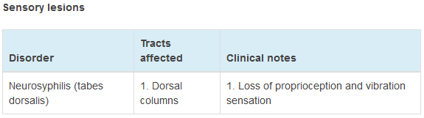

Syringes to take away the pain and relax the muscles
Leaving you feeling like a superhero (cape like loss of sensation to temperature)

