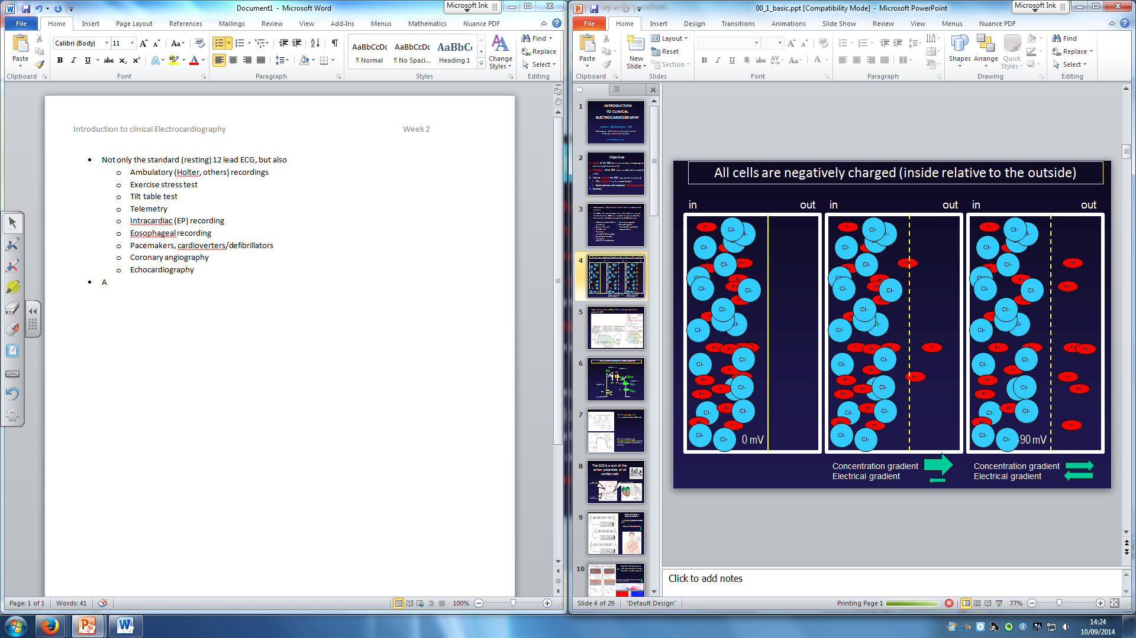
Not only the standard (resting) 12 lead ECG, but also
- Ambulatory (Holter, others) recordings
- Exercise stress test
- Tilt table test
- Telemetry
- Intracardiac (EP) recording
- Eosophageal recording
- Pacemakers, cardioverters/defibrillators
- Coronary angiography
- Echocardiography
All cells are negatively charged inside relative to the outside
- Some cells are excitable – can generate action potential
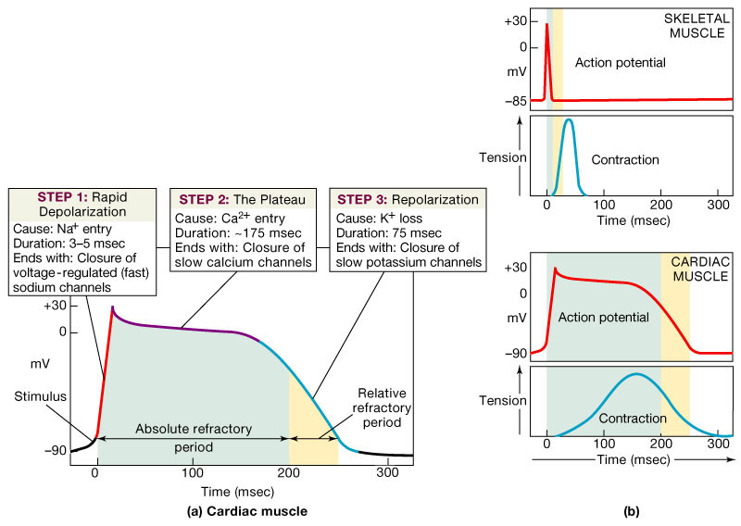

- Ionic current during the action potential

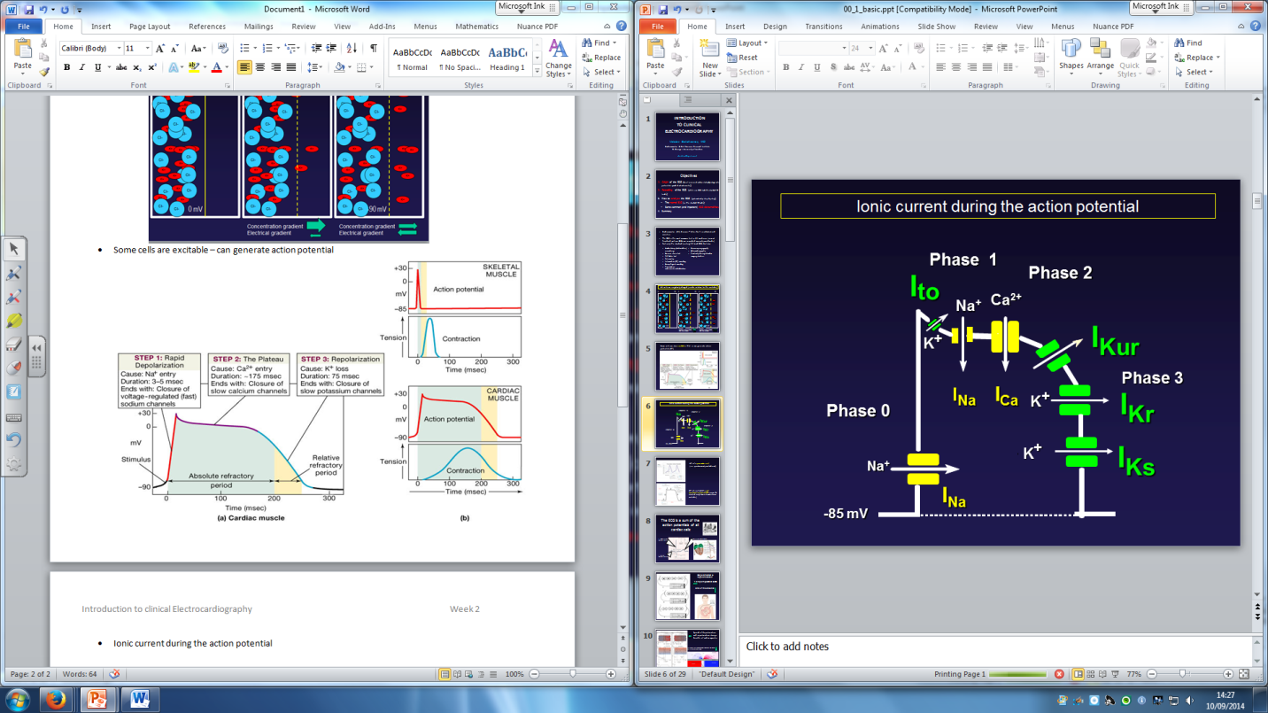

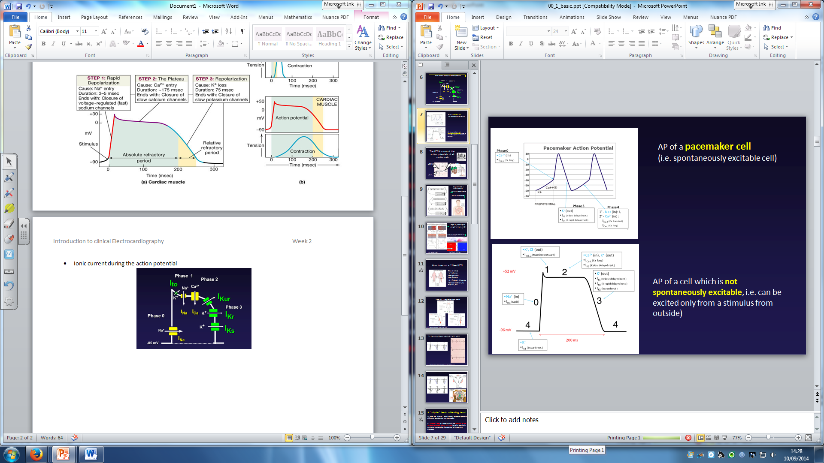

- Extracellular potential field created by the activation of a myocardial bundle
- Axes of the peripheral leads
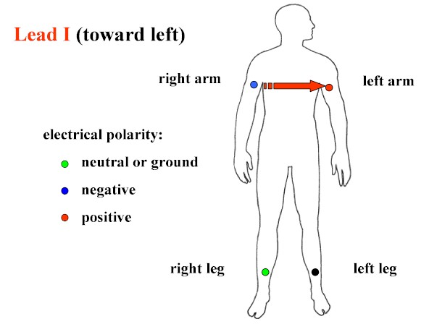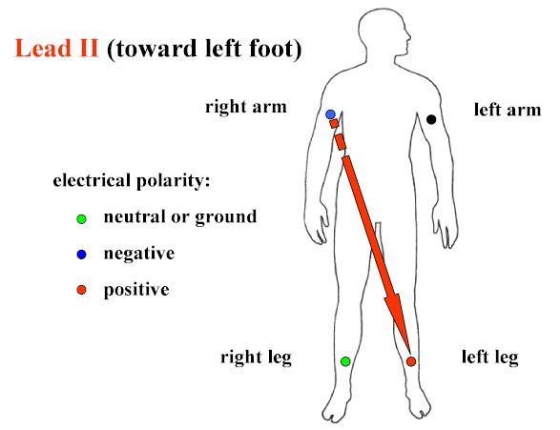
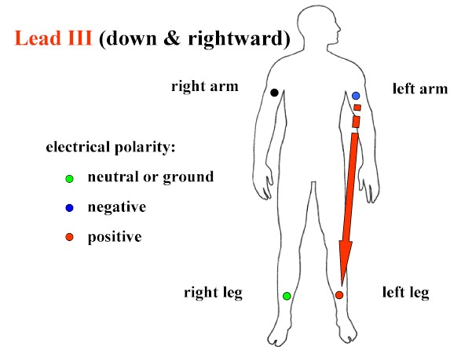REMEMBER, RIGHT HAND = NEGATIVE

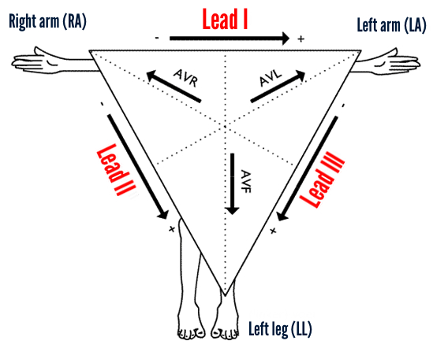
- All the leads are bipolar because they record the potential difference between the two electrodes
- A unipolar lead is a lead in which the potential of the negative electrode varies very little (remains practically the same) compared to the potential of the positive electrode
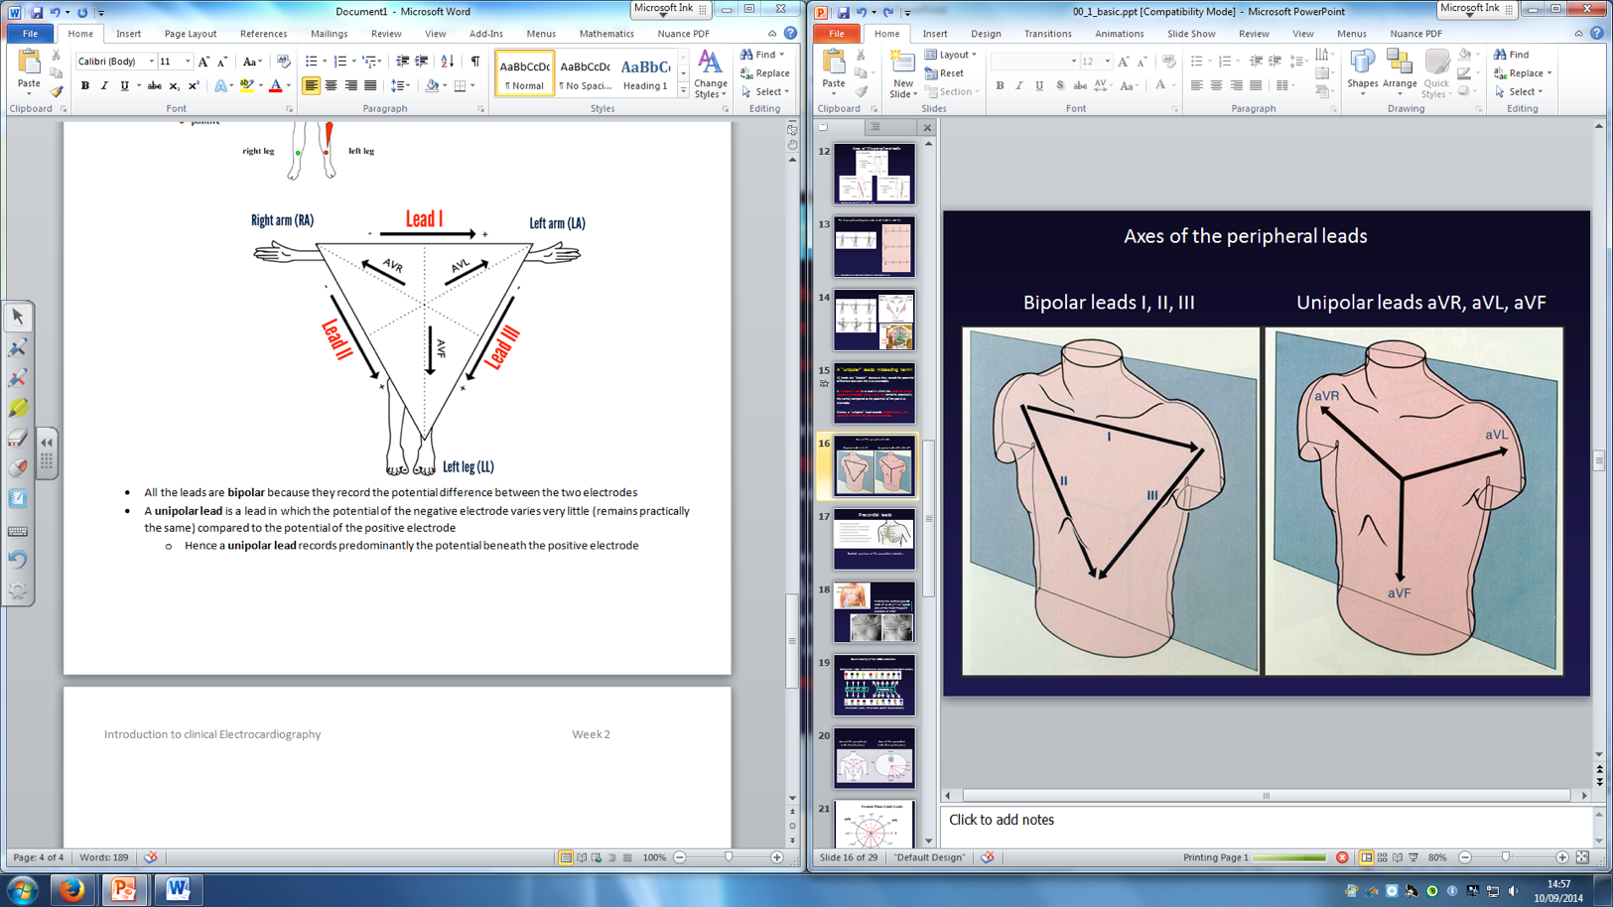
  - Hence a unipolar lead records predominantly the potential beneath the positive electrode

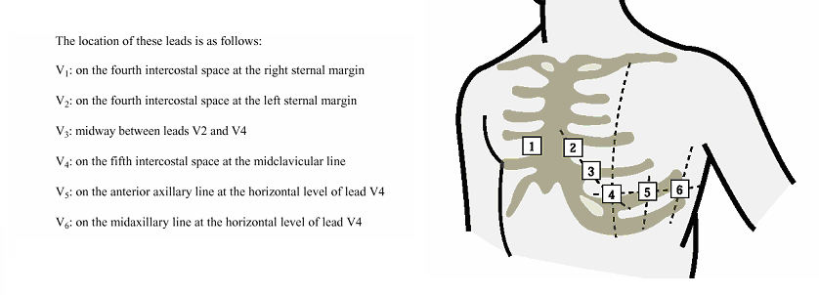
Precordial Leads

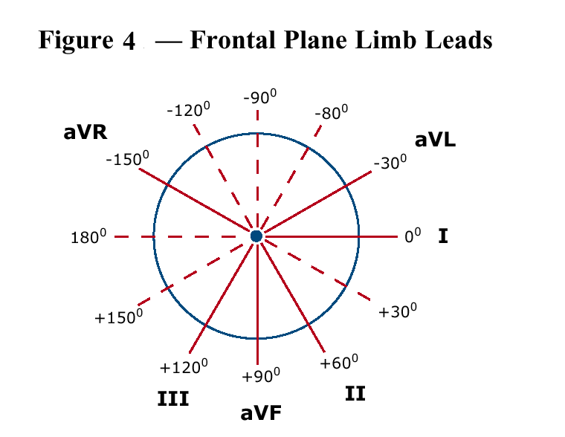
Lead I, II and III : 0, +60, +120
aVR, aVL, aVF: -150, -30, +90

- Frontal Plane Leads
  - A bipolar lead is a lead that has a positive and negative electrode (Leads I, II & III)
    - Lead I views the lateral surface of the left ventricle; the QRS in lead I is predominantly positive because the direction of depolarisation is towards the positive electrode
    - Lead II views the inferior surface of the left ventricle; The QRS in lead 2 is normally positive because the direction of depolarisation is predominantly towards the positive electrode; lead II is commonly used for cardiac monitoring because positioning of the positive and negative electrodes in this lead most closely resembles the normal pathway of current flow in the heart
    - Lead III views the inferior surface of the left ventricle; p waves in this lead may normally be positive, negative or biphasic and are usually of lower amplitude than lead II; R wave is not as tall as in lead 2
  - A lead that consists of a single positive electrode and a reference point is called a unipolar lead (augmented limb lead – aVR, aVL, aVF)
    - The electrical potential produced by the augmented leads is normally relatively small (the ECG amplifies this)
    - aVR views the base of the heart, primarily the atria and the great vessels - this lead does not view any walls of the heart; p waves and QRS complexes are normally negative in this lead because the direction of depolarisation is away from the positive electrode
    - aVL views the lateral wall of the left ventricle. The QRS in lead aVL is neither primarily positive nor negative because the direction of depolarisation is essentially perpendicular to the positive and negative electrodes
    - aVF views the inferior surface of the left ventricle – the QRS is positive because the direction of depolarisation is primarily toward the positive electrode
  - The reference point lies in the centre of the heart’s electrical field (left of the interventricular septum and below the AV junction)
- Horizontal Plane Leads
  - V1-6
  - Each electrode is a positive electrode – the negative electrode is found at the electrical centre of the heart thus the chest leads are also unipolar
- If the wave of depolarization moves towards the positive electrode, the waveform recorded on the ECG would be upright
- If the wave of depolarisation moves towards the negative electrode, the waveform recorded would be inverted
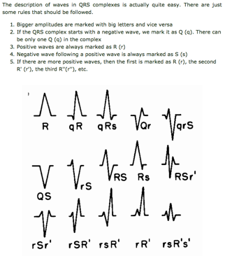
- A biphasic (partly positive, partly negative) waveform or a straight line is recorded when the wave of depolarization moves perpendicularly to the positive electrode
Check for correct lead placement
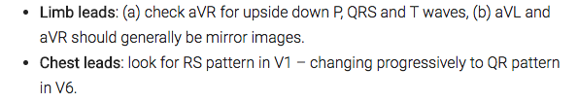
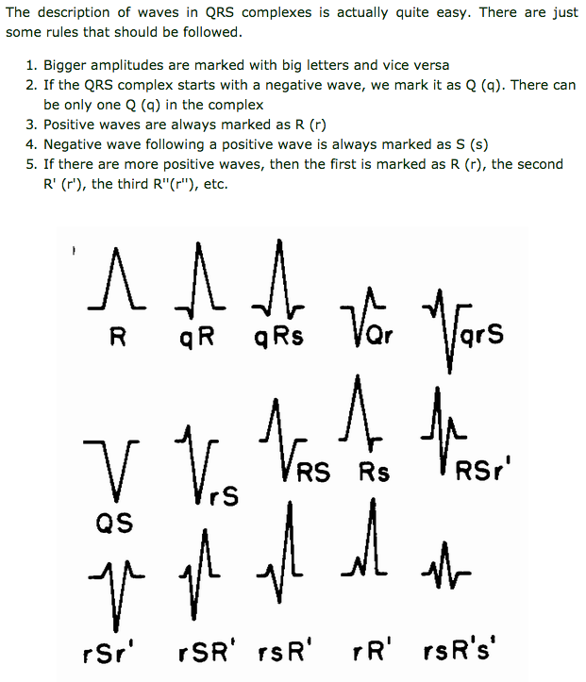
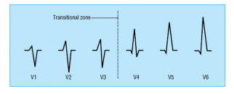
- R or S if >0.5Mv
- r or s if <0.5Mv
Conduction system
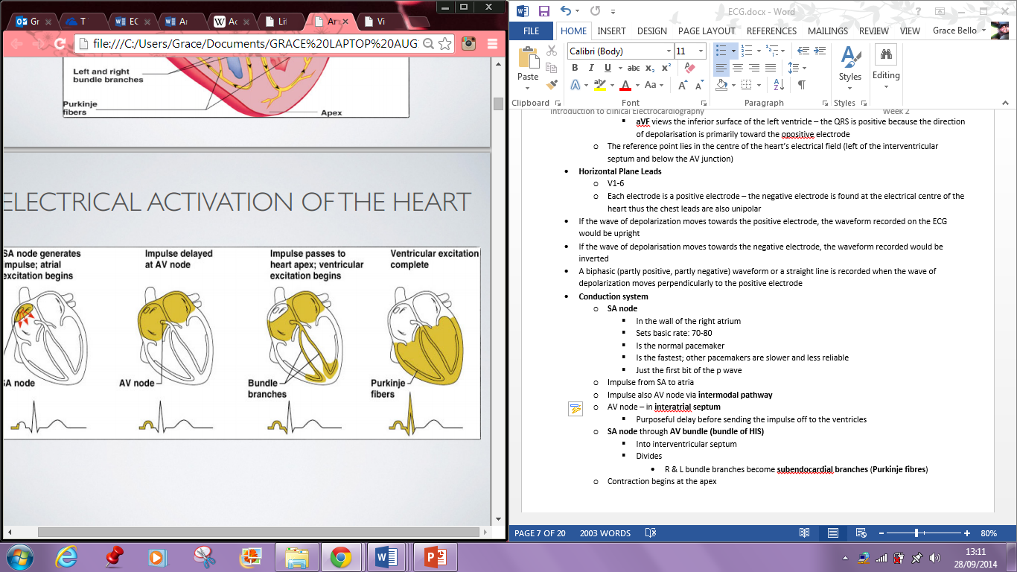
- SA node
  - In the wall of the right atrium
  - Sets basic rate: 70-80
  - Is the normal pacemaker
  - Is the fastest; other pacemakers are slower and less reliable
  - Just the first bit of the p wave
- Impulse from SA to atria
- Impulse also AV node via intermodal pathway
- AV node – in interatrial septum
  - Purposeful delay before sending the impulse off to the ventricles
- SA node through AV bundle (bundle of HIS)
  - Into interventricular septum
  - Divides
    - R & L bundle branches become subendocardial branches (Purkinje fibres)
- Contraction begins at the apex
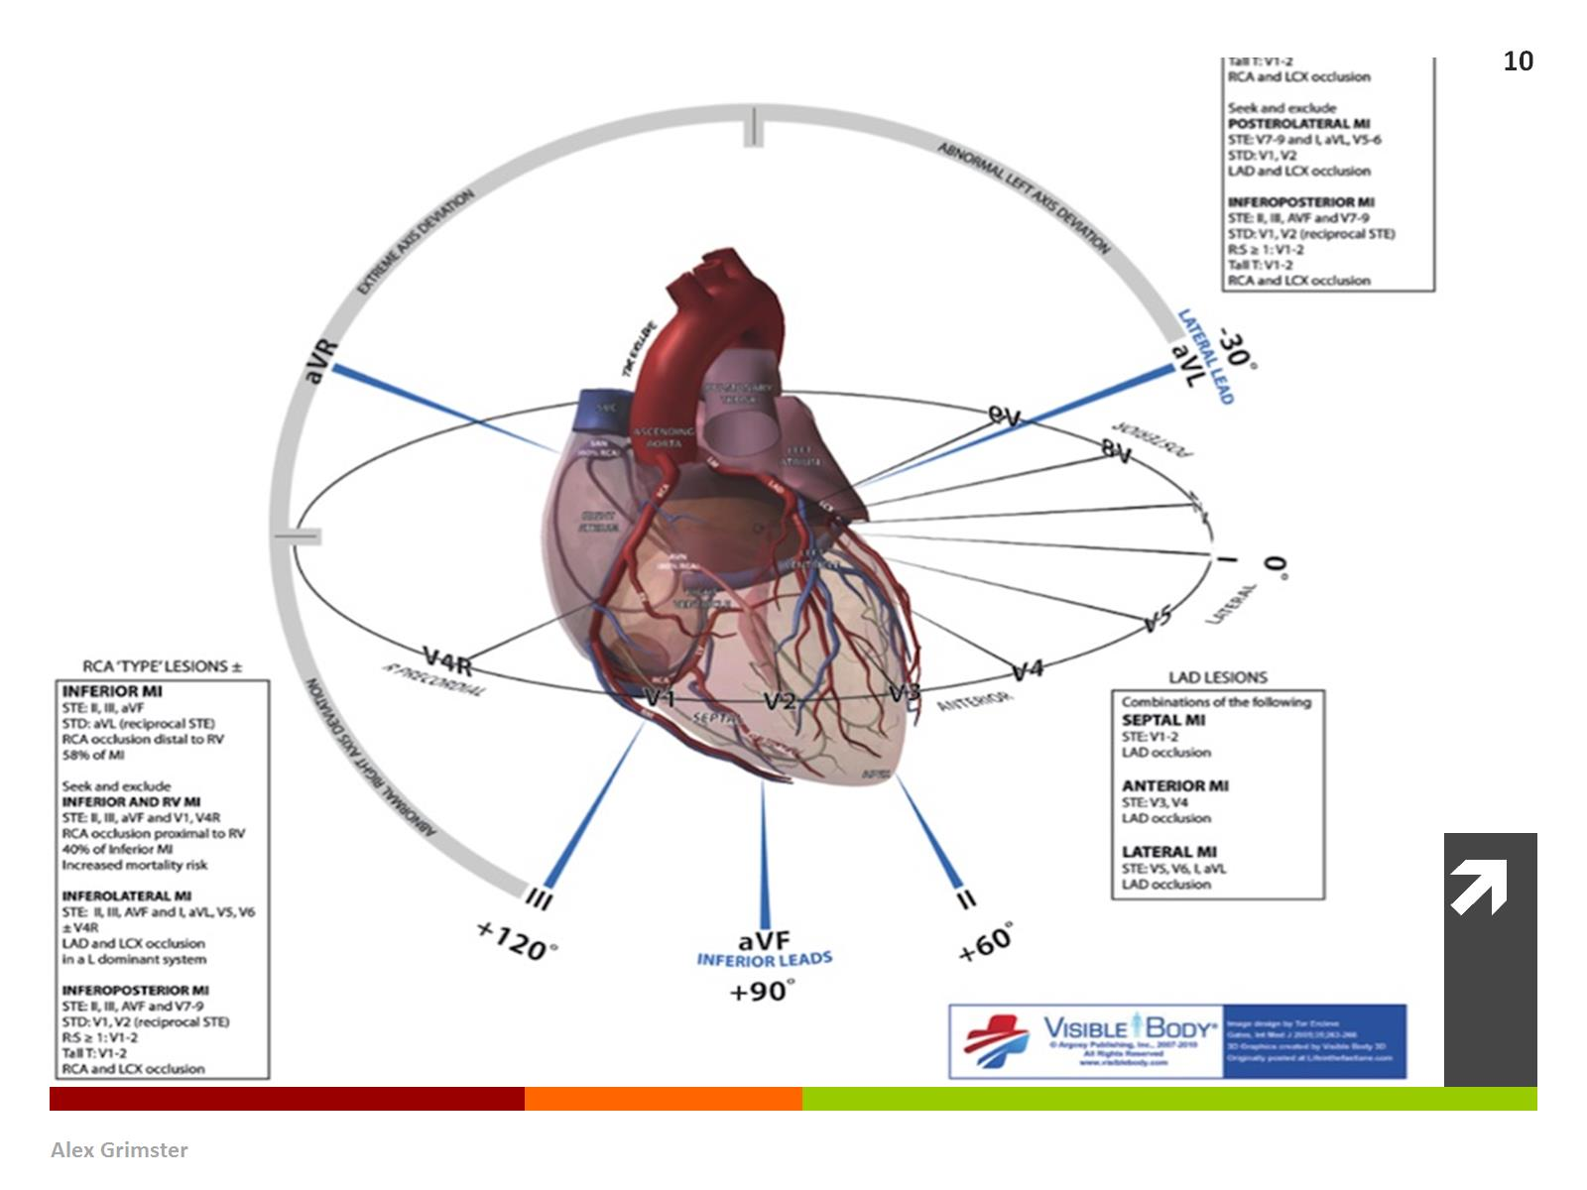
- Cardiac action potentials and the ECG
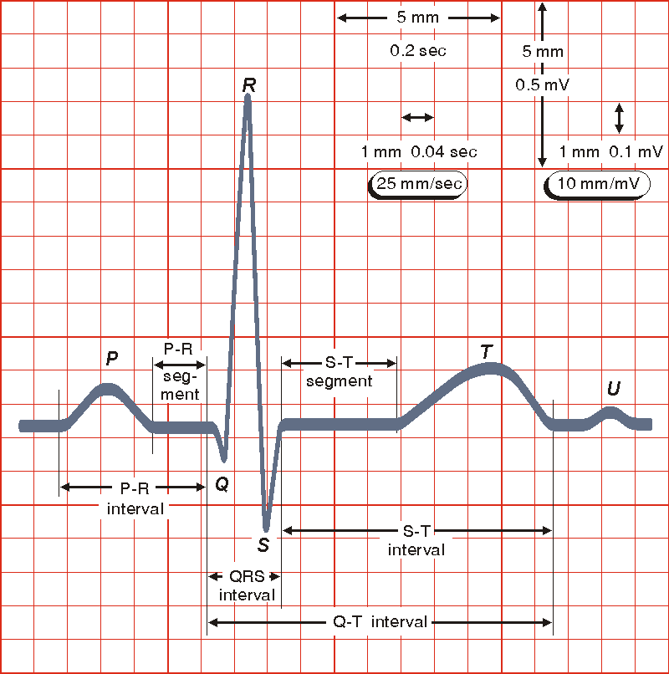
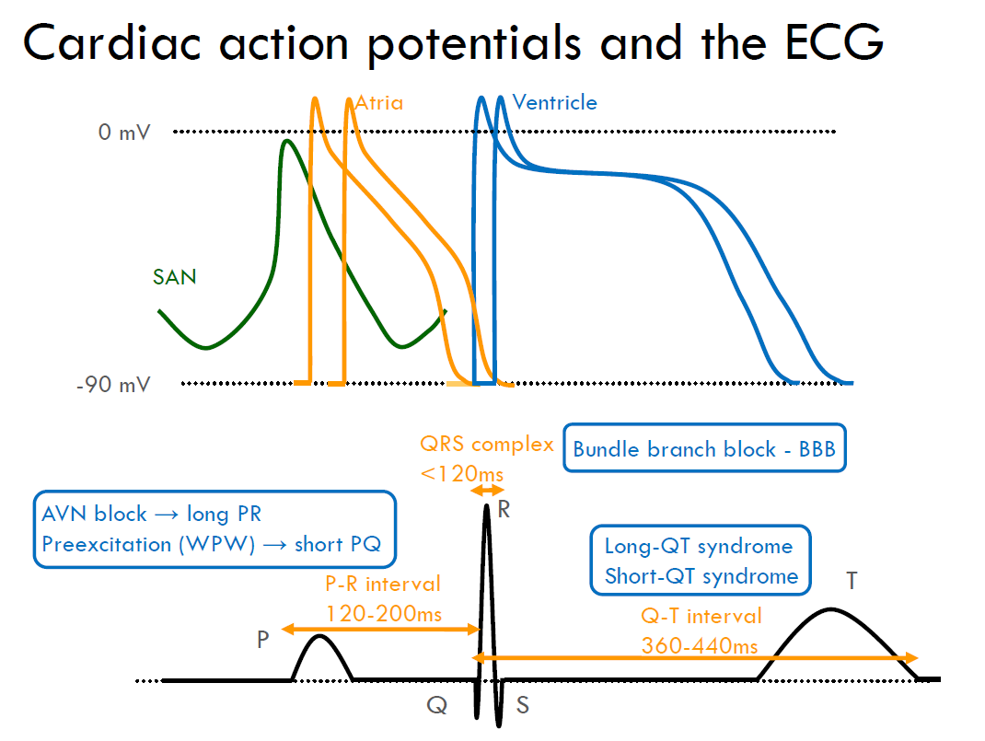
0.12 – 0.2s
1 large square
0.36 – 0.44s
2 large squares
s
3 small squares
- Analysing the ECG
  - What is the rhythm? (sinus or other, one or more rhythms)
  - What is the heart rate? (normal, too fast/slow, rhythmic or not)
    - To calculate ventricular rate, use the RR interval
      - 300/number of large squares
      - 1500/ number of small squares
  - Look at the P wave and PQ (PR) interval 0.12 – 0.2
    - Onset of P wave to onset of QRS complex
    - Time taken from SA node to ventricle
    - Measurement of AV node conduction time
    - Typically 120-200 mm/sec
    - 3-5 small squares
  - Analyse the QRS complex
    - Duration: normal <110ms, practically <120ms i.e. 3 small squares
    - Axis in the frontal plane (limb leads)
    - R/S progression in the horizontal plane (precordial leads)
    - Look for left or right ventricular hypertrophy
    - Look for bundle branch block
    - Early repolarisation, pre-excitation etc
  - Look at the ST segment
    - Isoelectric, depression, elevation, shape
      - ST elevation at the J point
        - Lead V2 & V3
          - Men <40:<0.25mV = 2.5mm
          - Men >40:<20mV = 2mm
          - Women <0.15mV = 1.5mm
  - The T wave
    - Direction (positive, negative, flat), amplitude, shape
    - The most variable part of the ECG
    - Positive in all leads except the AVR
    - Could be negative in V1, occasionally up to V3 in black women
    - Always asymmetrical
  - The QT interval (Corrected for the heart rate , QTc)
    - Too long, too short, normal
    - Sinus respiratory arrhythmia is a normal finding
    - 0.36 – 0.44
  - If there are U waves is it normal or abnormal?
- Criteria for normal sinus rhythm
  - A P wave morphology P wave (atrial contraction) precedes every QRS complex
  - The rhythm is regular but varies slightly during respirations
  - The rate ranges between 60 and 100 beats per minute
  - The P waves maximum height at 2.5mm in II and/or III
  - The P wave is positive in I and II, and biphasic in V1
  - PR interval between 0.12 – 0.20 seconds in duration
  - QRS complex less than 0.12 seconds in width and consistent in morphology
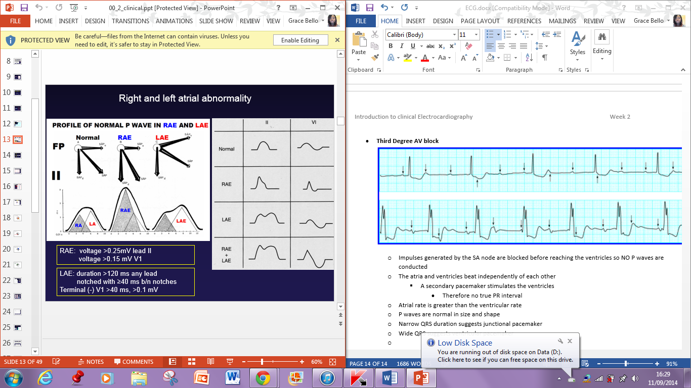

Arrhythmias
Symptoms that may be reported by a patient experiencing arrhythmias
SHuPPP:
- Presyncope/syncope
- Hypotension
- Palpitations
- Pulmonary oedema
- Chest pain
- A heartbeat that’s too fast, too slow or irregular (uneven)
- Caused by problems with the hearts electrical system
  - Includes
    - Atrial fibrillation
    - Atrial tachycardia
    - Bradycardia
    - Heart Block
    - Ventricular fibrillation
    - Ventricular tachycardia

Mechanisms of tachyarrhythmia’s
- Rentry – 90% of arrhythmias
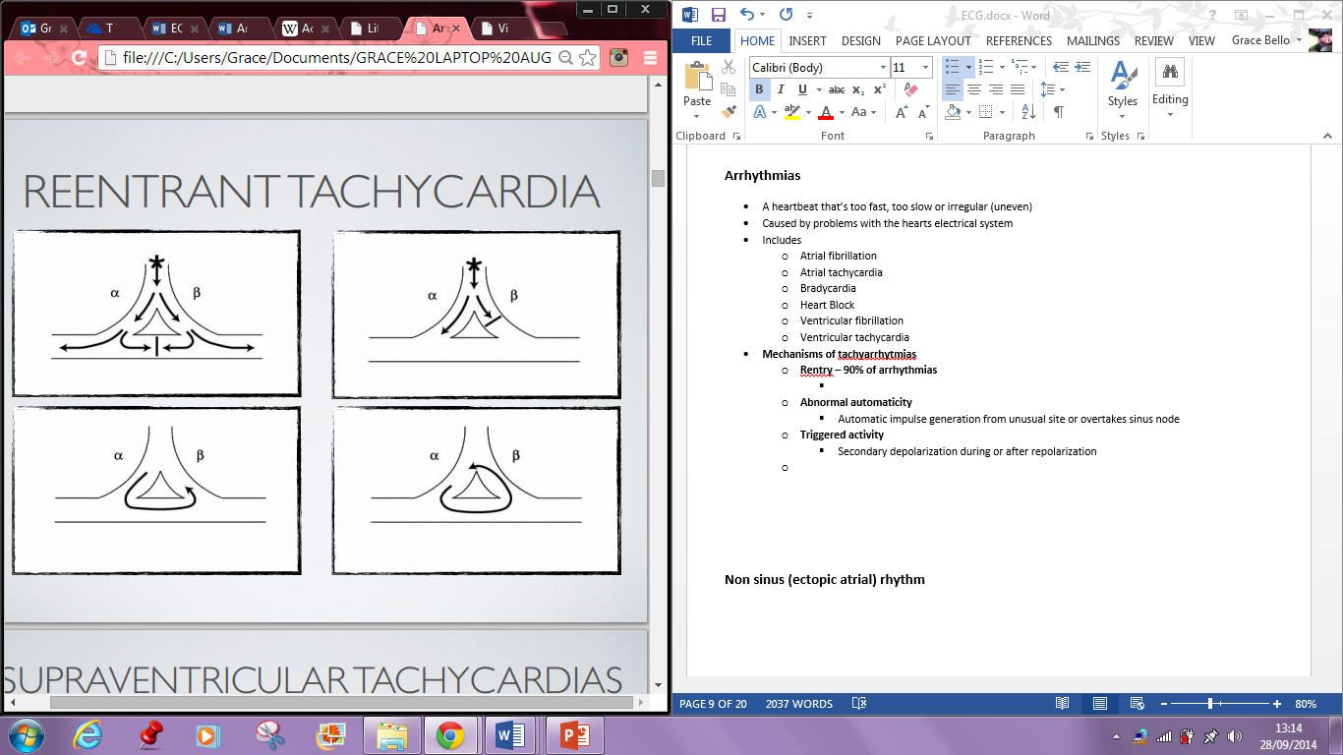
    - 1st diagram: conductions cancer each other out
    - 2nd diagram: impulse on B side is slower and so therefore slow limb has a chance to be ready for the next impulse causing circular re-entry
  - Abnormal automaticity
    - Automatic impulse generation from unusual site or overtakes sinus node
  - Triggered activity
    - Secondary depolarization during or after repolarization

- Supraventricular tachycardias (originating above the bundle of HIS)
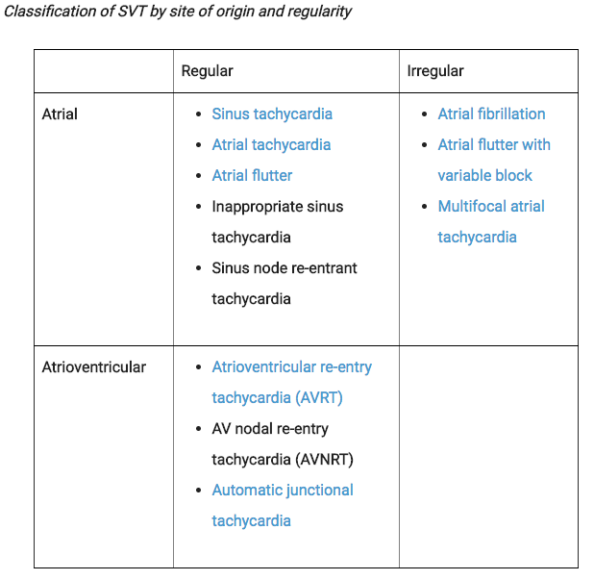
  - General Management according to the Grey Book
    - a 12 Lead ECG must be obtained in all cases
    - It is important to diagnose the disturbance accurately, as therapy will depend on the particular rhythm
    - Paroxysms should be terminated and preventative treatment started
    - Chronic arrhythmias which can not be terminated should be slowed
    - Chronic AF, Atrial Flutter and Atrial tachycardia can be treated with digoxin or other AV nodal blocking drugs (diltiazem, beta blockers)
    - Junctional re-entry tachycardias are most effectively terminated with IV adenosine 6mg over 2 secs; If no effect is seen within 1 minute, give a second injection of 12mg – further doses are not recommended
      - Should not be given to patients with asthma or severe obstructive airways disease
  - AVNRT – AV nodal re-entrant tachycardia
    - Occurs when a re-entry circuit forms within or just next to the AV node
      - (dual AV NODE)
    - Circuit usually involves two anatomical pathways in the right atrium
      - The fast pathway
        - (anterior) Superior and posterior to the AV node
      - The slow pathway
        - Located posterior to the AV node often following the anterior margin of the coronary sinus
    - These pathways are formed from tissue that behaves very much like the AV node

    - In common AVNRT, the anterograde conduction is via the slow pathway and the retrograde conduction is via the fast pathway (slow-fast AVNRT)
      - Because the retrograde conduction is via the fast pathway, stimulation of the atria (which produces the inverted P wave) will occur at the same time as stimulation of the ventricles which causes the QRS complexes
        - As a result, the inverted P waves may not be seen on the surface ECG since they are buried with the QRS complexes
        - Often the retrograde (fast) P wave is visible but also in continuity with the QRS complex
          - Pseudo r’ wave seen best in V1
          - Pseudo S waves seen in inferior leads
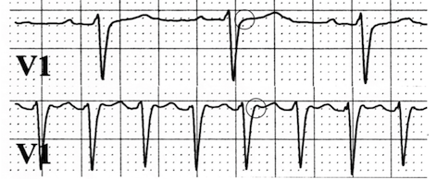
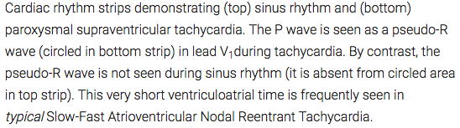

    - In uncommon AVNRT
      - The anterograde conduction is via the fast pathway and the retrograde conduction is via the slow pathway (fast-slow AVNRT)
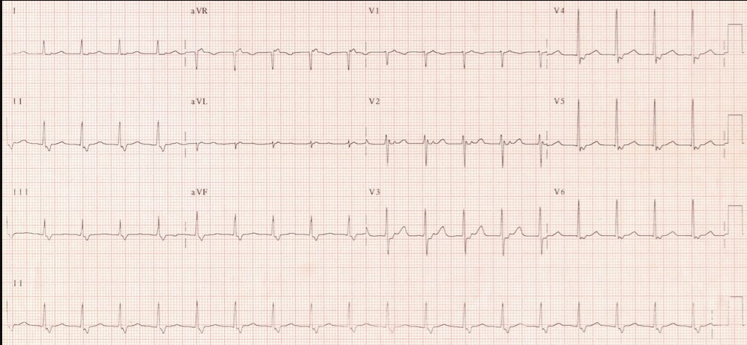
      - Because the retrograde conduction is via the slow pathway, stimulation of the atria will be delayed by the slow conduction tissue and will typically produce an inverted P wave that falls after the QRS complex on an ECG

    - Multiple slow pathways can exist so that both anterograde and retrograde conduction are over slow pathways (slow-slow AVNRT)
    - An overactive thyroid increases the risk of AVNRT
  - AVRT – Atrioventricular reciprocating tachycardia
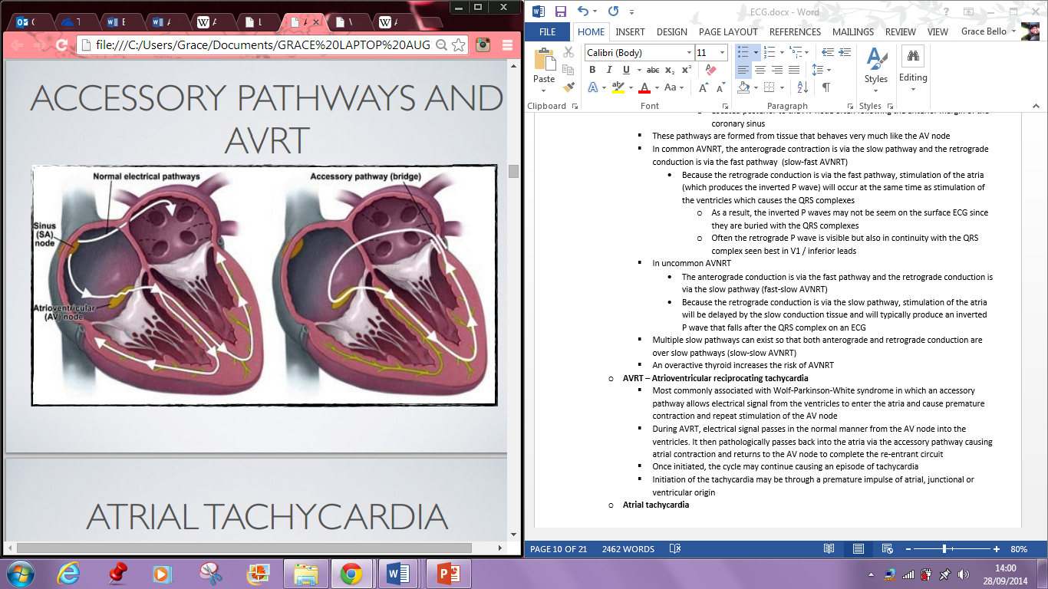
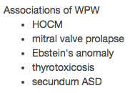
    - Most commonly associated with Wolf-Parkinson-White syndrome in which an accessory pathway allows electrical signal from the ventricles to enter the atria and cause premature contraction and repeat stimulation of the AV node
    - During AVRT, electrical signal passes in the normal manner from the AV node into the ventricles. It then pathologically passes back into the atria via the accessory pathway causing atrial contraction and returns to the AV node to complete the re-entrant circuit
    - Once initiated, the cycle may continue causing an episode of tachycardia
    - Initiation of the tachycardia may be through a premature impulse of atrial, junctional or ventricular origin
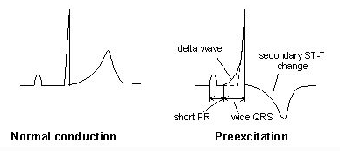
    - Because the normal conduction route through the purkinje fibres is fast, the QRS complex is usually narrow however if conduction does not go through the normal route, wide QRS complex is present
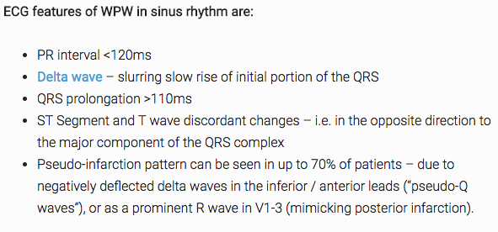

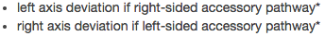
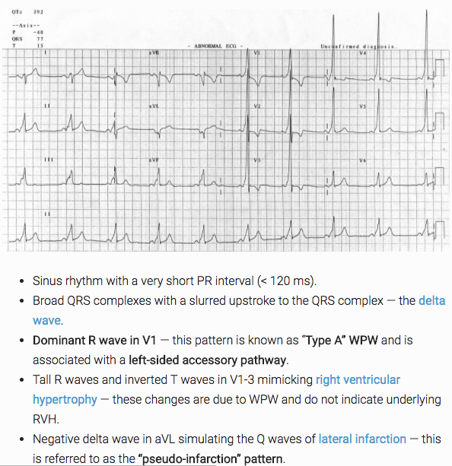

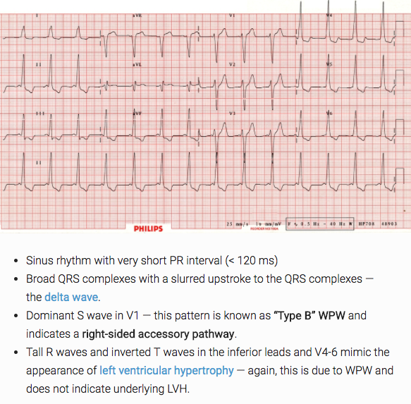

Wolf Parkinson White
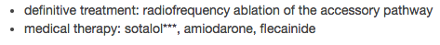
General Supraventricular Tachycardia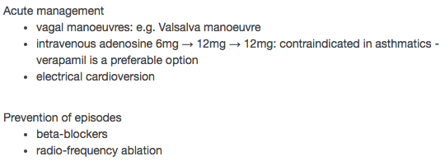
Do not give AV Nodal Blocking drugs to WPW Patients with pre-excited atrial arrhythmias
Atrial Tachycardia
- Another form of supraventricular tachycardia originating within the atria but outside of the sinus node
- Both atrial flutter and multifocal atrial tachycardia are specific types of atrial tachycardia
- Usually due to a single ectopic focus
- Multiple causes include digoxin toxicity, atrial scarring, catecholamine excess, congenital abnormalities, idiopathic
- Non sinus (ectopic atrial) rhythm
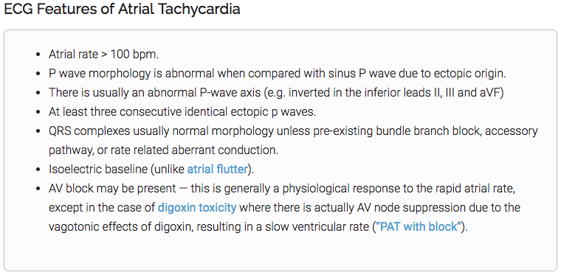
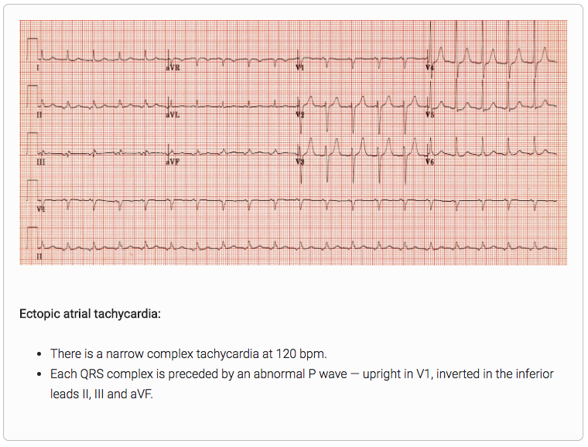
- P waves that begin at a site other than the SA node (ectopic P waves) may be positive or negative in lead II
- Premature atrial contraction (can occur in couplet)
- P wave – premature or hidden
- If the ectopic pacemaker is in the atria, the P wave will be upright
- If the ectopic pacemaker is in the AV junction, the P wave will be negative (inverted) in lead II
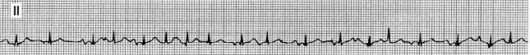
- P waves are superimposed on the preceding T waves (p wave is almost hidden in the T wave)
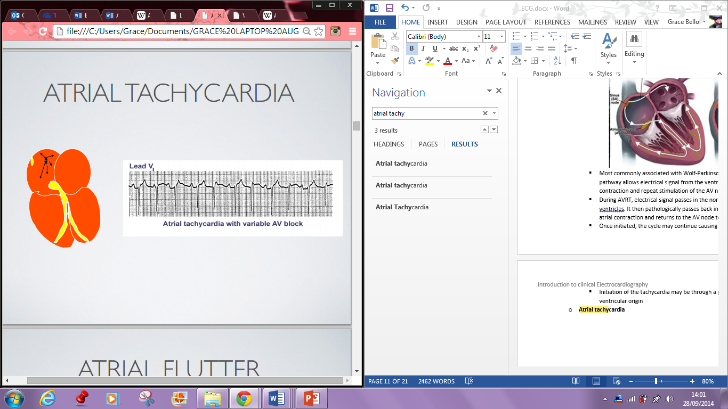
Ectopic Atrial Tachycardia
- type of atrial arrhythmia in which the hearts electrical impulse comes from an ectopic atrial pacemaker rather than from the the SA node
- Characterised by very regular rates ranging from 140-220bpm
- The rapid rate shortens diastole resulting in a loss of kick, reduced cardiac output, reduced coronary perfusion and ischaemic myocardial changes
- Atrial tachycardia can occur in patients with normal hearts. In those cases, the condition is commonly related to excessive use of caffeine or other stimulants, marijuana use, electrolyte imbalances, hypoxia and physical or psychological stress
- The P wave usually has a 1:1 ratio with the QRS complex unless a block is present
Atrial Flutter
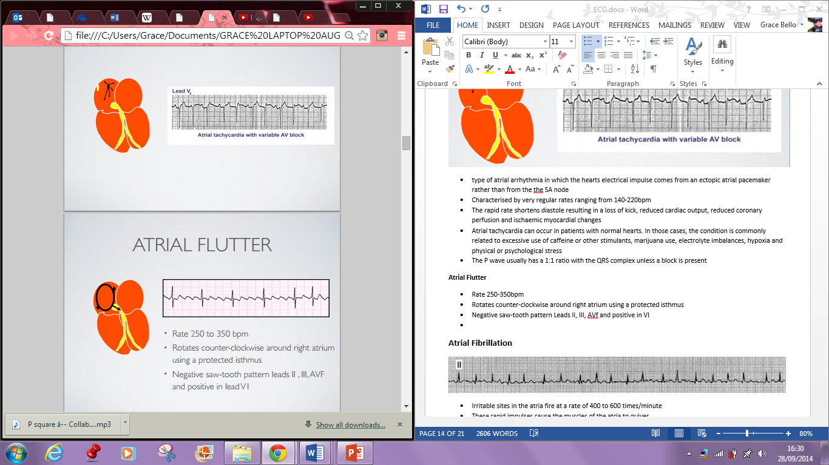
- Rate 250-350bpm
- Rotates counter-clockwise around right atrium using a protected isthmus
- Negative saw-tooth pattern Leads II, III, AVf and positive in VI
- On an ECG, P waves lose their distinction due to the rapid atrial rate – the waves blend together in a saw toothed appearance called flutter waves, or f waves
- Atrial flutter is commonly associated with second degree block. In that instance, the AV node fails to allow conduction of all the impulses to the ventricles. As a result, the ventricular rate is slower
- Commonly found in patients with severe mitral valve disease, hyperthyroidism, pericardial disease and primary myocardial disease
- Drugs rarely work

- First line treatment is ablation
  - This is where a laser dissolves the tissues and cures the arrhythmia – this blocks the electrical impulses in the part of the heart that is causing the abnormal rhythm
  - If ablation is going to destroy the hearts natural pacemaker – the AV node – you may be fitted with a pacemaker days or even weeks earlier
  - radiofrequency ablation of the tricuspid valve isthmus is curative for most patients
Atrial Fibrillation
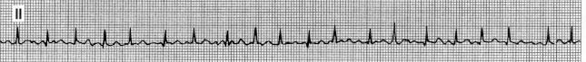
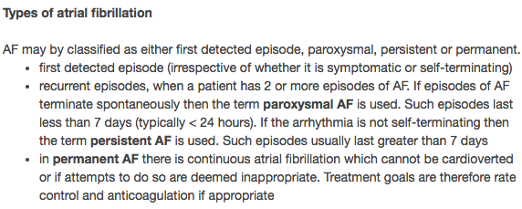
- Irritable sites in the atria fire at a rate of 400 to 600 times/minute
- These rapid impulses cause the muscles of the atria to quiver
- This results in ineffectual atrial contraction, decreased stroke volume, a subsequent decrease in cardiac output and a loss of atrial kick
- The AV node attempts to protect the ventricles from the hundreds of impulses bombarding it per minute by blocking the impulses
- The ventricular rate and rhythm are determined by the degree of blocking by the AV node of these rapid impulses
- The irregular conduction of impulses through the AV node produces a characteristic irregularly irregular ventricular response
  - If you see R waves that look irregular, suspect atrial fibrillation
- There is no P wave, just an erratic baseline
- Not directly life threatening
- There are two key parts of managing patients with AF
  - 1. Rate/rhythm control
    - Rate Control: accept that the pulse will be irregular, but slow the rate down to avoid negative effects on cardiac function
      - Beta Blocker/Rate limiting calcium channel blocker is used first line to control the rate in AF
      - Second line: combination any two of the following
        - Digoxin
    - Rhythm control: try to get the patient back into, and maintain, normal sinus rhythm. This is termed cardioversion. Drugs (pharmacological cardioversion) and synchronised DC electrical shocks (electrical cardioversion) may be used for this purpose
      - Note the moment a patient switches from AF to sinus rhythm presents the highest risk for embolism leading to stroke
        - For this reason patients must either have had a short duration of symptoms (less than 48h) or be anticoagulated for a period of time prior to attempting cardioversion
          - According to the Grey book, AF of revent onset <24h is best terminated by IV Flecainide (1-2mg/kg over 10 min; maximum dose 150mg)
          - In the presence of heart failure or acute ischaemia, amiodarone should be used (300mg bolus via large bore cannula in a large venin or centrally then a 900mg 24h infusion)
        - Patients with AF for >24h should be anticoagulated
      - Pharmacological Cardioversion
        - Sotalol
        - Amiodarone
        - Flecainide
    - NICE advocate using a rate control strategy except in a number of specific situations such as coexistent heart failure, first onset of AF or where there is an obvious reversible cause
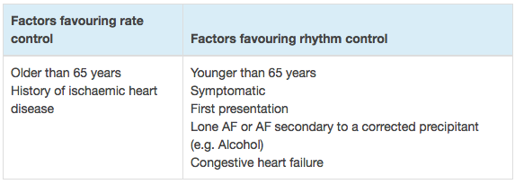
  - 2. Reducing stroke risk
    - Do not offer aspirin monotherapy solely for stroke prevention to people with atrial fibrillation
    - Only consider Aspirin/clopidogrel dual therapy if anticoagulation is CI or not tolerated AND CHA2DS2-VASc>2
    - Use CHA2DS2-VASc (New NICE guidelines)
    - 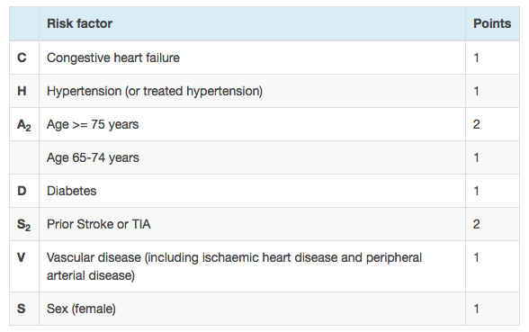
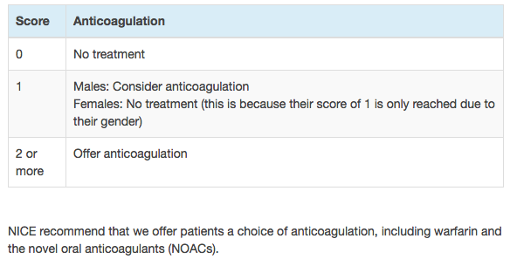
    - Time in therapeutic range, if poor consider novel anticoagulants
      - Apixaban
      - Dagbigatran
      - Rivaroxaban
      - Computer assisted dosing
    - Consider modifiable bleeding risk factors like
      - Uncontrolled hypertension
      - Labile INRs
      - Concurrent medications (Aspirin/NSAIDs)
      - High alcohol consumption
      - Don’t withhold anticoagulation solely because person is at risk of falls

- Management based on Onset
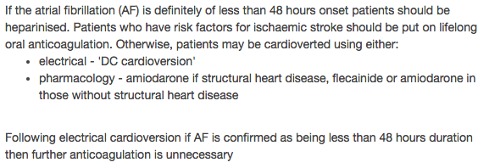
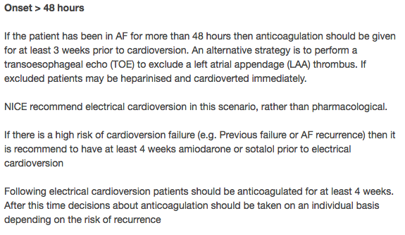

Ventricular Tachycardia
- Broad complex tachycardia originating from a ventricular ectopic focus
- It has the potential to precipitate ventricular fibrillation and hence requires urgent treatment
- Monomorphic VT
  - Most commonly caused by myocardial infarction
- Polymorphic VT:
  - Less common and usually uses presyncope, syncope or cardiac arrest depending on the duration of the arrhythmia
  - A subtype of polymorphic VT is torsades de pointes which is precipitated by prolongation of the QT interval (management of Torsades de pointes: IV Magnesium Sulphate)
  - When temporary pacing, beta blockers and potassium and magnesium replacement may treat the arrhythmia successfully but precipitants such as certain drugs or hypokalaemia must be removed
  - Be aware of subarachnoid haemorrhage as a cause
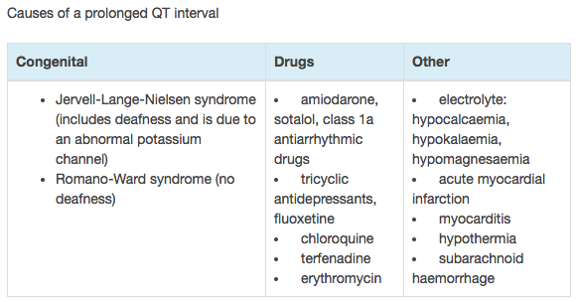

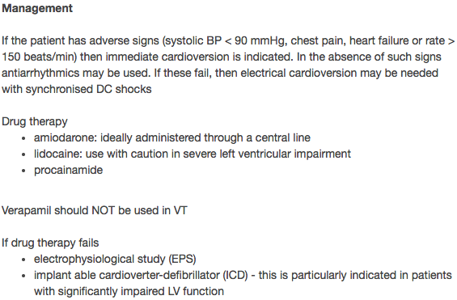
Grey Book
- If stable, treatment should be with lidocaine 1.5mg/kg IV – if this terminates tachycardia continue as an infusion at 2mg/min for up to 24 hours
- If tachycardia continues, an additional bolus of 0.5 – 0.75mg/kg should be considered
  - Otherwise, consider giving procainamide (20mg/min at a dose of 10-15mg/kg up to a total of 1g, stopping infusion if arrhythmia resolves, hypotension develops or QRS widens significantly
  - Another option is Amiodarone (200mg bolus via large bore cannula in a large vein or centrally, then a 900mg 24h infusion)
- Do not give more than one additional drug, polypharmacy can be dangerous
- If drug therapy fails or the patient has poor cardiac function, direct current cardioversion
  - (150J-200J Biphasic) under sedation is the best therapy
- The administration of magnesium, initial dose 8mmol (4mL or 50%) may help when the arrhythmia is refractory
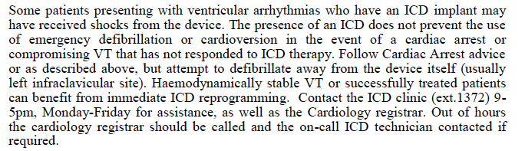
Ventricular Ectopic
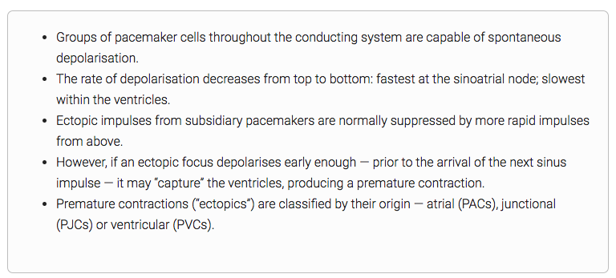
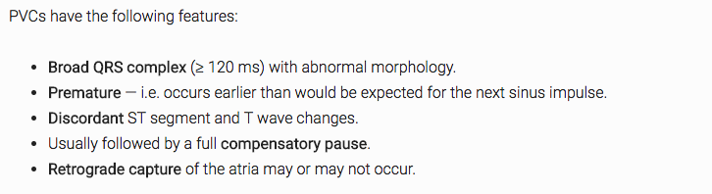
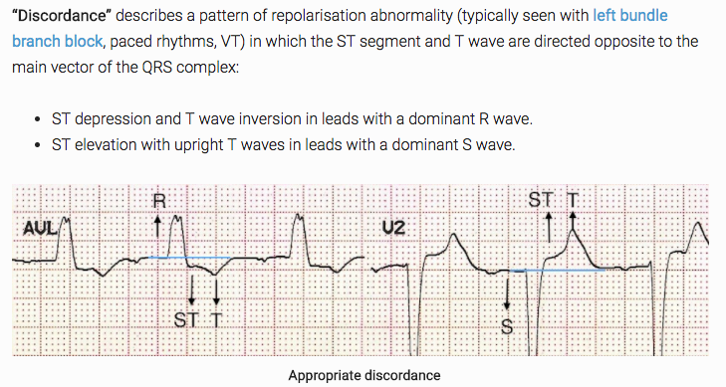
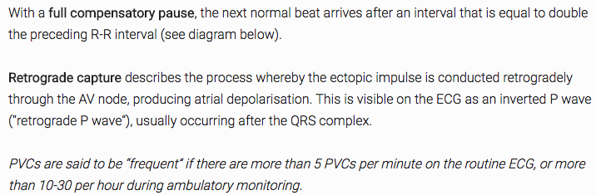
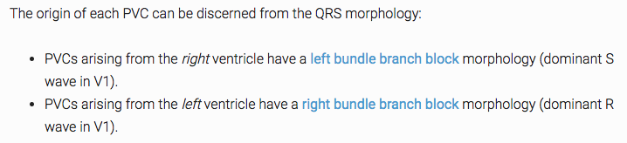

- These are ubiquitous and do not require treatment unless they are causing symptoms such as palpitations or dizziness
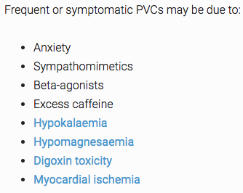
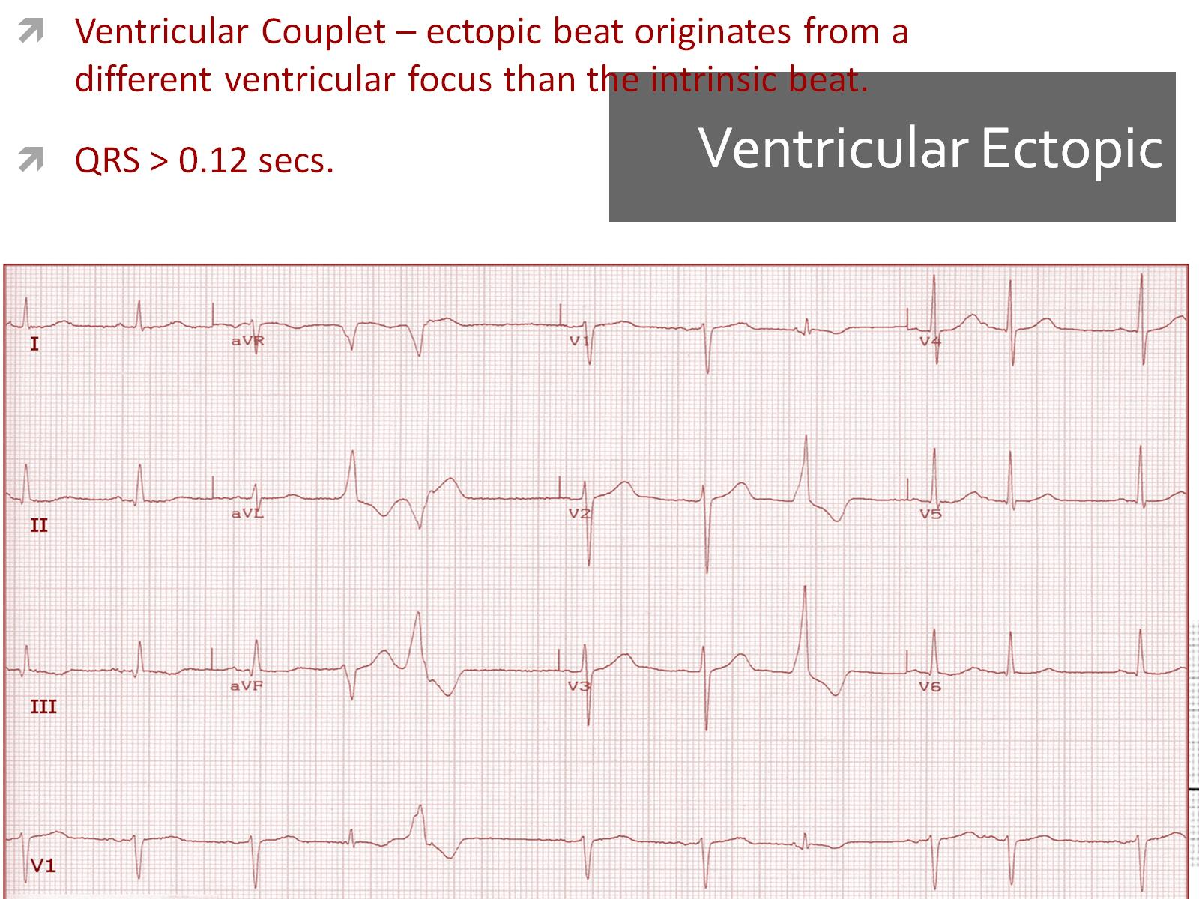
- Ventricular couplet – ectopic beat originates from a different ventricular focus than the intrinsic beat
- QRS > 0.12 seconds
- The T wave is usually in the opposite direction of the QRS complex
- Often the ectopic beats are not preceded by a P wave

Case Studies:
Sinus bradycardia 38bpm in a healthy 35yo male – very fit
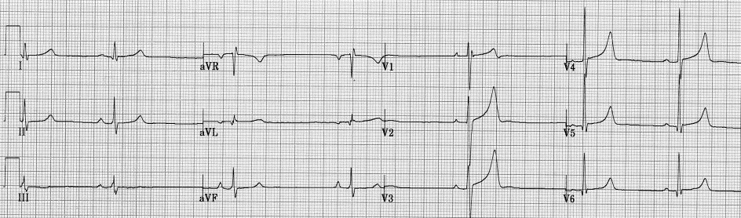
- Originates from the sinus node and has a rate that is lower than normal. In humans, bradycardia is generally defined to be a rate of under 60 beats per minute
- PR interval between 0.12 – 0.20 seconds in duration
- QRS complex less than 0.12 seconds in width and consistent in morphology
- Sinus bradycardia requires no treatment unless it is causing symptoms
- If treatment is deemed necessary, give atropine 600 – 1200mcg IV in the first instance
- Persistent symptomatic bradycardia requires pacing (temporary or permanent)
- If temporary pacing is required, transvenous pacing under ray control is optimal
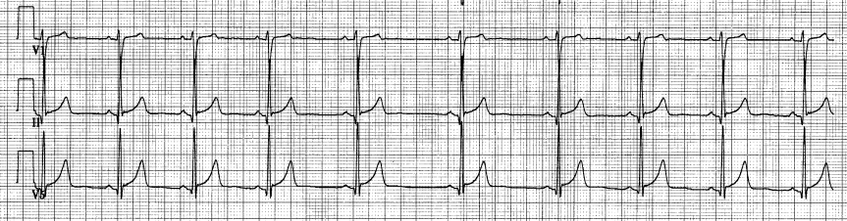
Respiratory sinus arrhythmia – Normal finding (absence of it is abnormal)

- This is normal phenomenon that occurs with changes in intrathoracic pressure
- Heart rate increases with inspiration (R-R intervals shorten) and decreases with expiration (R-R intervals lengthen)
Ventricular Fibrillation
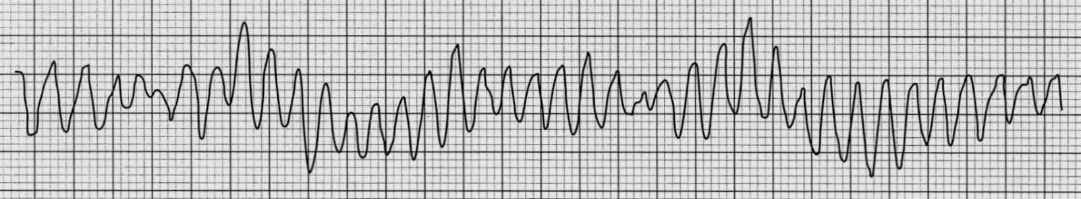
- Rate cannot be determined because there are no discernible waves or complexes to measure
- Rhythm is rapid and chaotic with no pattern or regularity
- P waves, PR interval, QRS duration are all not discernible
Artefact
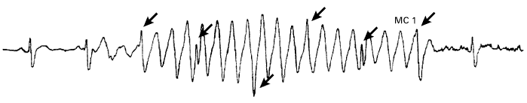

Atrioventricular Block
- First Degree
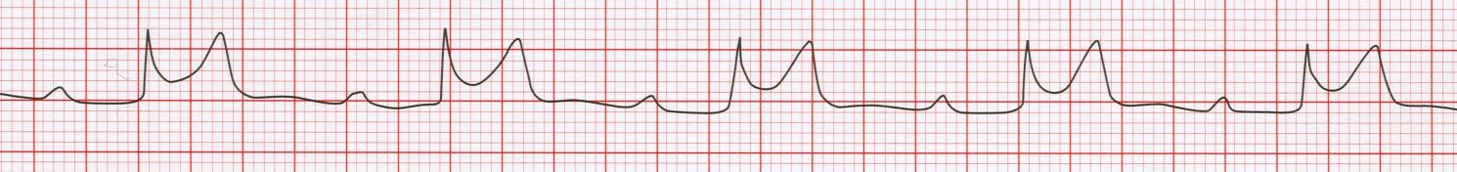
  - A PR interval of normal duration (0.12 – 0.20 seconds) indicates the electrical impulse was conducted normally through the atria, AV node, bundle of His, bundle branches and Purkinje Fibres
  - In first degree AV block, all components of the ECG tracing are usually within normal limits except the PR interval – more than 0.20 seconds
    - This is because the electrical impulses travel from the SA node through the atria but there is a delay in impulse conduction usually at the level of the AV node
- Second Degree

  - Type I usually occurs at the level of the AV node
  - Irregular ventricular rhythm (so longest R-R interval and shortest interval needs to be used to calculate the rate and noted)
  - More P waves than QRS complexes
    - Atrial rate is greater than the ventricular rate
    - Atrial regular, ventricular irregular
  - PR interval lengthens wih each cycle until a P wave appearss without a QRS complex
  - The problem is not in the SA node but somewhere in the conduction system below it
  - After ACUTE MI, patients with 2nd degree block will need temporary pacing if the block is impairing cardiac function
  - Lengthening in the PR intervals

- Second Degree AV Block, type I (Mobitz I; Wencheback) 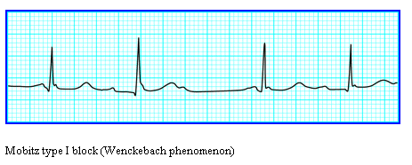
  - Prolongation of the PR interval until a dropped beat occurs
- Second degree AV block, type II (Mobitz Ii) 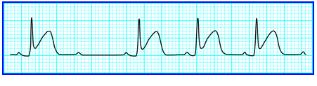
  - Occurs below the AV node
  - More serious - frequently progresses to third-degree AV block
  - Atrial rate greater than ventricular rate
  - Atrial regular, ventricular irregular
  - Some P waves not followed by QRS complex
  - PR intervals within normal limits or slightly prolonged but constant for the conducted beats
  - There may be some shortening of the PR interval that follows a non conducted P wave
- Third Degree AV block
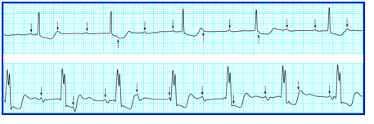
  - Impulses generated by the SA node are blocked before reaching the ventricles so NO P waves are conducted
  - The atria and ventricles beat independently of each other
    - A secondary pacemaker stimulates the ventricles
      - Therefore no true PR interval
  - Atrial rate is greater than the ventricular rate
  - P waves are normal in size and shape
  - Narrow QRS duration suggests junctional pacemaker
  - Wide QRS suggests ventricular pacemaker
- Clinical signs of pathological bradycardia (heart block)
  - First degree heart block does not cause any noticeable symptoms, most people are only aware they have the condition on a random ECG
  - In second degree heart block, there may be light-headedness, dizziness and fainting
    - There may also be chest pain, SOB, fatigue, hypotension
    - SHUPPP symptoms
Management
- Patients with symptomatic block usually require immediate pacing even if symptoms have resolved upon arrival
- Asymptomatic patients with marked bradycardia (rate <40bpm, a broad complex escape rhythm and/or significant QT prolongation (>500ms) are at risk of arrest and will require urgent pacing – preferably achieved by prompt implantation of a permanent pacemaker but a temporary one may suffice for overnight/over weekend management
- Complete AV block associated with inferior myocardial ischaemia is usually transient but will require temporary pacing if the patient is compromised or permanent pacing if the heart rate remains slow
- When associated with anterior infarction temporary pacing is always indicated regardless of the presence or absence of symptoms
- Patients with acute bifasicular block following acute myocardial infarction should be considered for temporary pacing particularly if the PR interval is increased or increasing
- Temporary pacing can be achieved rapidly by a balloon flotation wire but is rarely needed
- Contact the cardiology registrar for advice and X ray guided temporary pacemaker
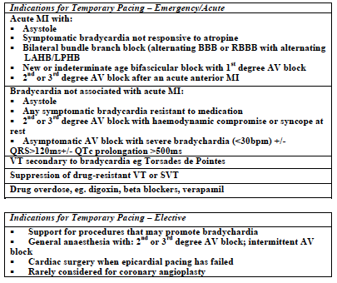

AXIS DEVIATION
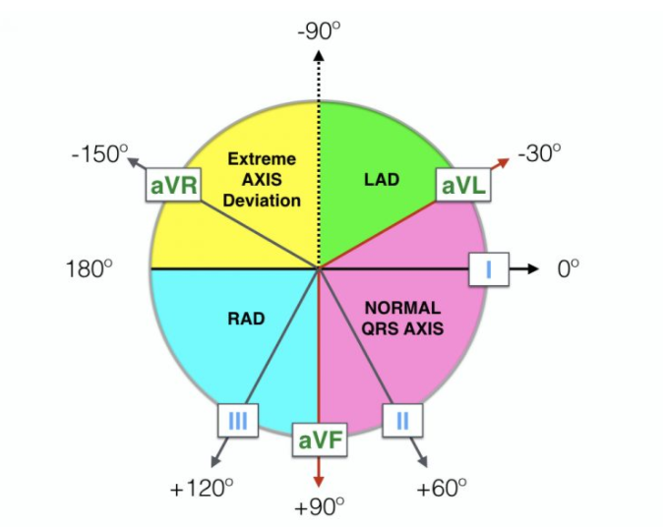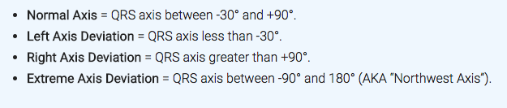
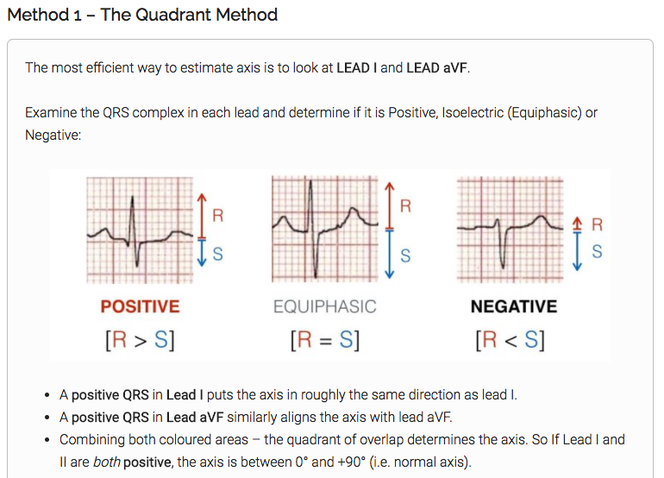
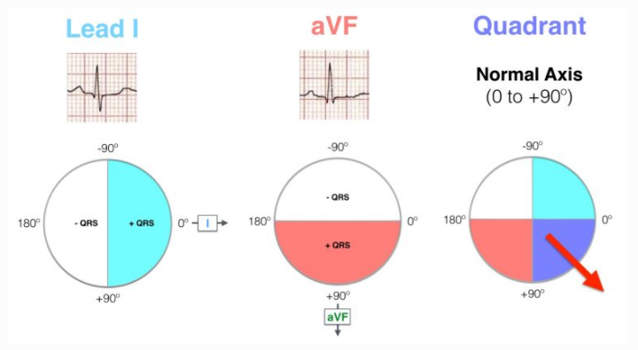
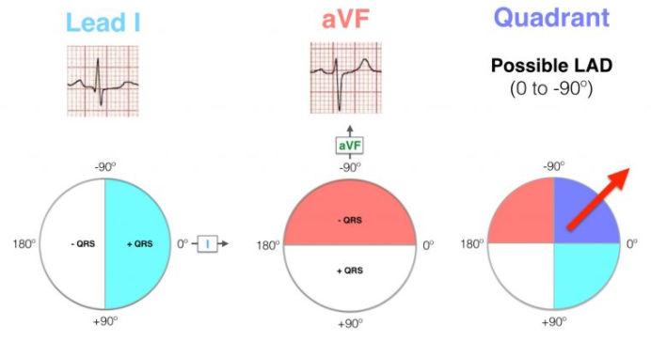
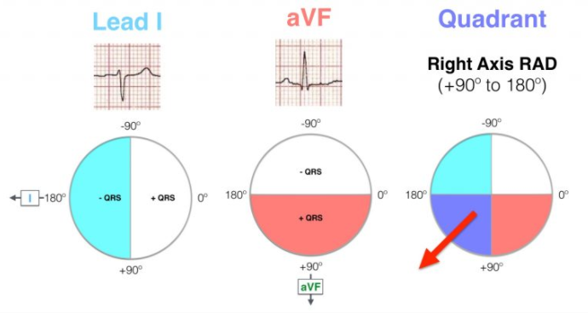
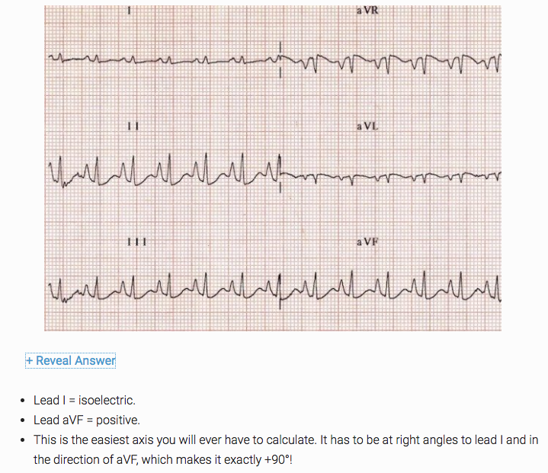
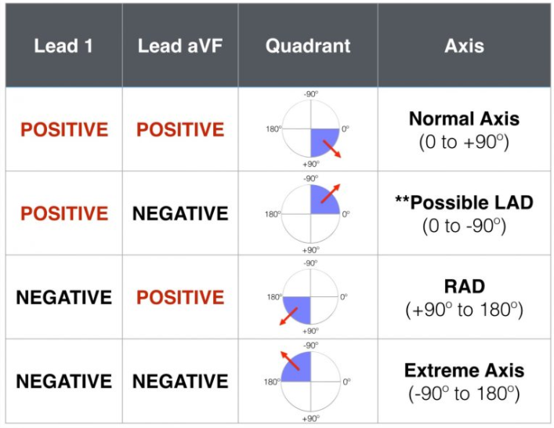
Lead II tends to be the same as lead aVF/III in regards to +ve/negative
Seen in patients with emphysema who typically have a vertically orientated heart

Right Axis Deviation
Causes:
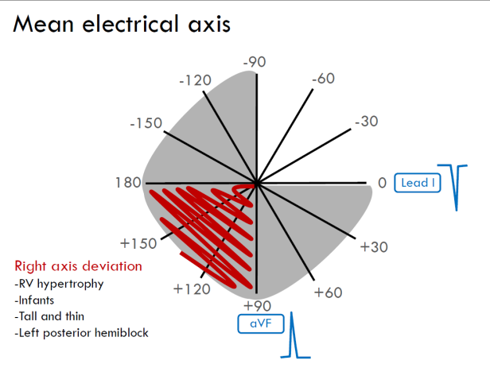
- Right ventricular hypertrophy
- Left posterior hemiblock
- Chronic lung disease cor pulmonale
- Pulmonary embolism
- Ostium secundum ASD
- Wolf Parkinson White Syndrome – Left sided accessory pathway
  - In majority of cases, or in a question without qualification, Wolf-Parkinson-White syndrome is associated with left axis deviation
- Normal in infant <1 years old
- Minor RAD in tall people
  - Vertically orientated heart

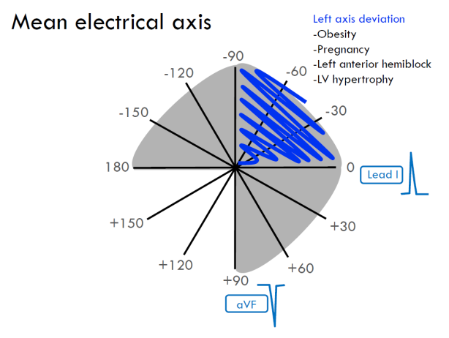
Left axis deviation
Causes:
- Left anterior hemiblock
- Left Bundle Branch Block
- Wolf Parkinson white syndrome (right sided accessory pathway)
- Hyperkalaemia
- Congenital: Ostium primum ASD, Tricuspid atresia
- Minor LAD in obese people

Extreme axis:
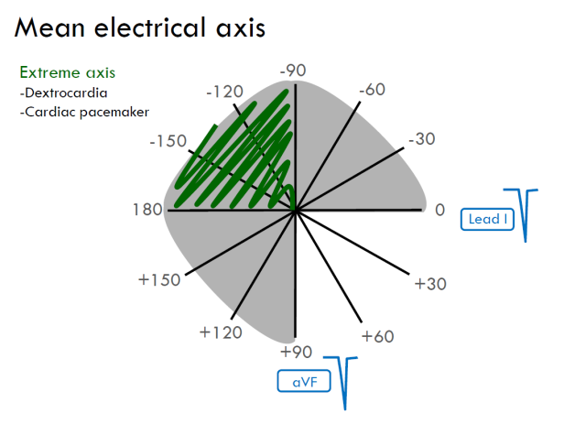
Precordial Leads
- We describe the R wave progression and the transition zone (from predominantly negative to predominantly positive QRS – normally at V3 or V4 – Late or early transition)
Normal and Abnormal Q waves
- Normal Q waves (septal depolarisation) are <40ms (0.04s)
- The duration of the Q wave is more important than its depth
- Abnormal (wide) Q waves tell tale sign of MI
Acute myocardial infarction of the inferior wall and lateral wall of the left ventricle
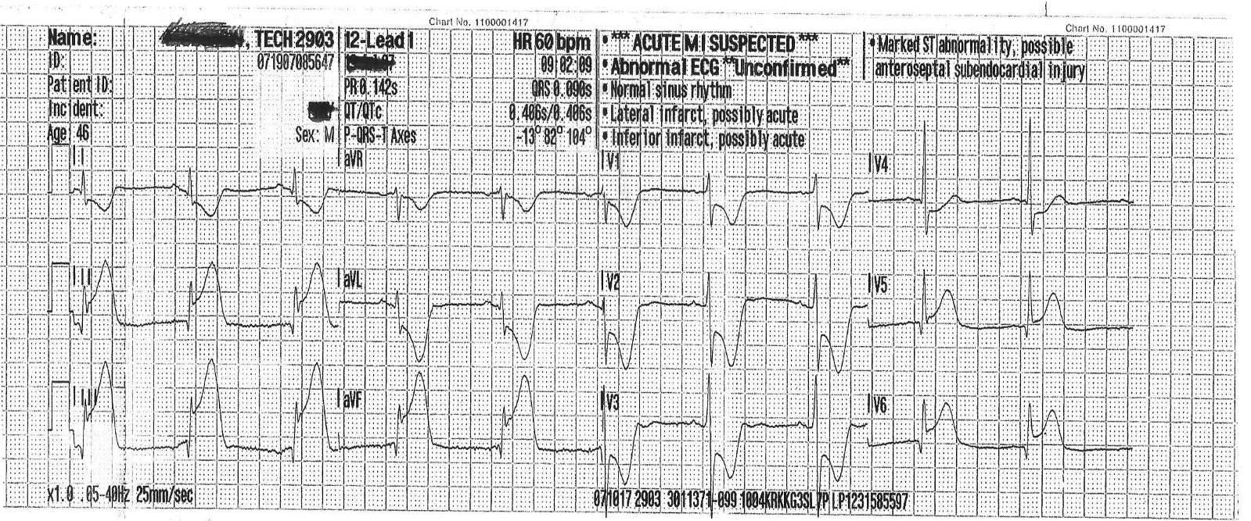
Left Ventricular Hypertrophy
- Secondary to conditions such as aortic stenosis and hypertension
  - Also aortic regurgitation , mitral regurgitation and coarctation of the aorta
  - Hypertrophic cardiomyopathy
- This results in increased R wave amplitude in the left sided ECG leads (I, aVL and V4-V6) and increased S wave depth in the right sided leads (III, aVR, V1-3)
- The thickened LV wall leads to prolonged depolarisation (increased R wave peak time) and delayed repolarisation in the lateral leads
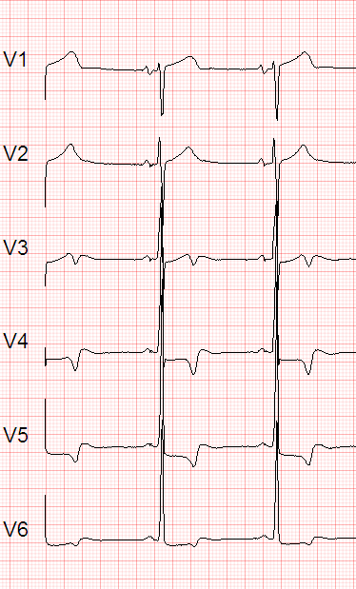
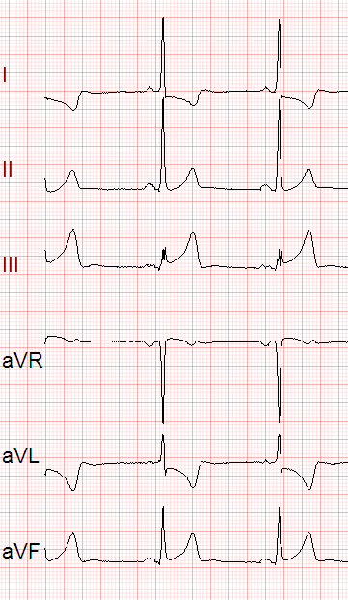

Right Ventricular Hypertrophy
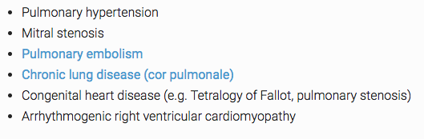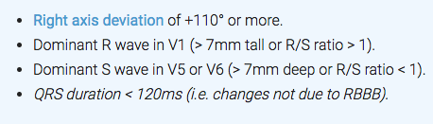
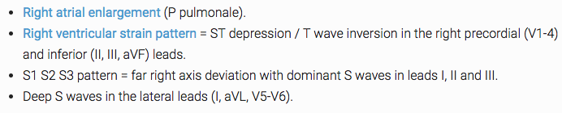

Right Bundle Branch Block
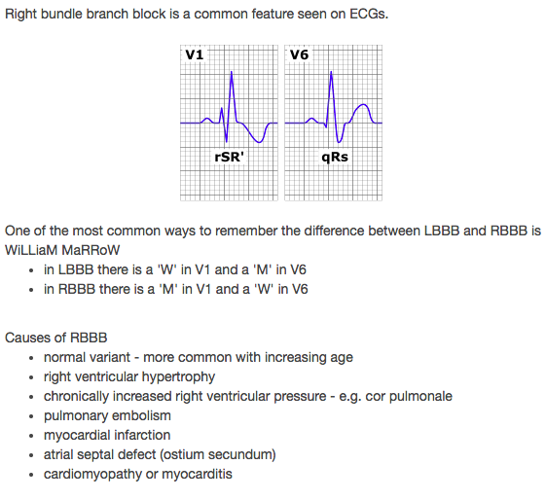
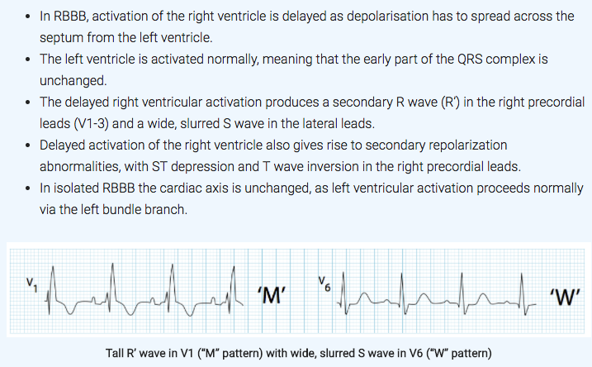
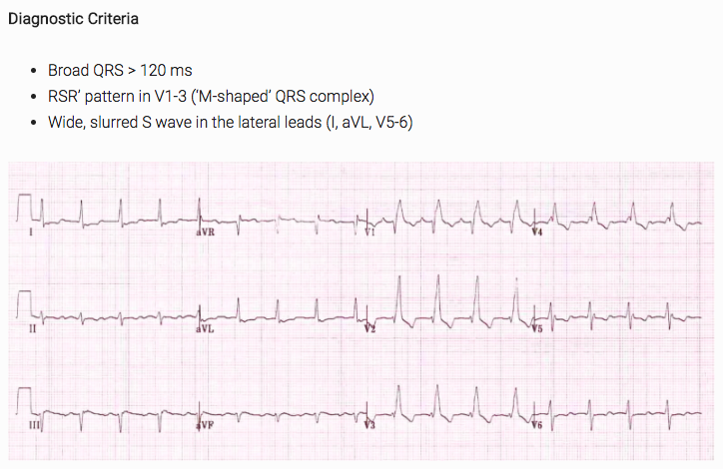

Left Bundle Branch Block
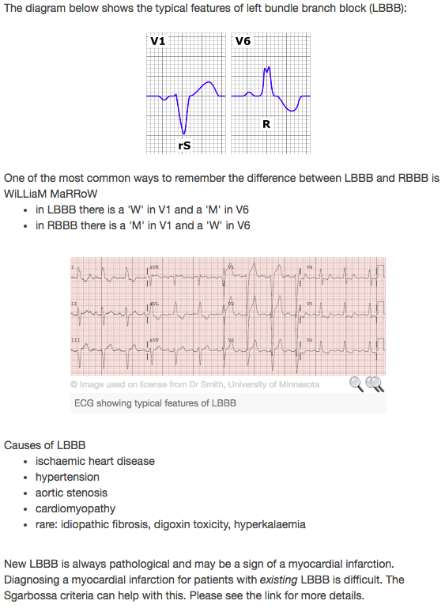

Differential diagnosis for collapse
- Acute coronary syndrome
- Ventricular arrhythmias
- Atrioventricular block
- Acute atrial fibrillation
- Congestive heart failure
- Volume depletion
- Sinus node dysfunction
- Aortic stenosis
- Upper GI bleeding
- Lower GI bleeding
- Neurally mediated
- Orthostatic hypotension
- Migraine
- Seizure
- Wolf-Parkinson-White syndrome / pre-excitation syndrome
- Cardiac tamponade
- Aortic dissection
- Pulmonary embolism
- Ruptured AAA
- Brugada syndrome
- Long QT syndrome
- Hypertrophic cardiomyopathy
- Mitral stenosis
- Atrial Myxoma
- Subclavian steal syndrome
- Ectopic pregnancy
- Hypoglycaemia
- Addison’s disease
- Acute vertebrobasilar stroke
- Psychogenic pseudosyncope

Management of Arrhythmias
- Physical manoeuvres
  - Aim is to increase the parasympathetic nervous supply to the heart, resulting in blocking of electrical conduction through the AV node
    - This can slow down or stop a number of arrhythmias that originate above or at the AV node
  - These manoeuvres are collectively known as vagal manoeuvres
- Antiarrhythmic drugs
  - Rate control
  - Anticoagulation
    - Warfarin
    - Heparin
    - Aspirin
- Electricity
  - Cardioversion is achieved pharmacologically or via the application of a shock synchronised to the underlying heartbeat
    - It is used for the treatment of supraventricular tachycardia
    - In elective cardioversion, the recipient is usually sedated or lightly anesthetized for the procedure
  - Defibrillation differs in that the shock is not synchronised
    - It is needed for the chaotic rhythm of ventricular fibrillation and is also used for pulseless ventricular tachycardia
    - Often, more electricity is required for defibrillation than cardioversion
  - Implantable cardioverter-defibrillator is used to accomplish defibrillation or cardioversion
  - Cardiac pacing
    - May be necessary for reversible causes of slow heartbeats or bradycardia (for example from MI or drug overdose)
  - Electrical cautery
    - This is where abnormal areas of conduction are located very accurately and subsequently destroyed with heat, cold, electrical or laser probes

