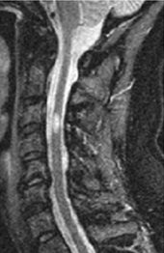
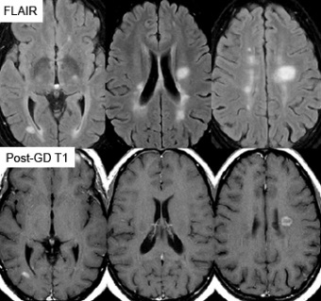
Motor/senosry, Uthoffs, Lhermitte, Tremor/Trigeminal Neuralgia, Impotence/Incontinence, Paraesthesia, Loss of balance(ataxia), Eyesight affected(optic neuritis/INO)
Investigations
- Diagnosis requires 2 CNS LESIONS DISSEMINATED IN SPACE & TIME
- MRI brain/C spine
  - Reveals hyperintensities especially in the periventricular region
- Vision evoked potentials
  - Shows delayed conduction in the visual pathways (e.g. previous subclinical optic neuritis)
- CSF Evaluation
  - Electrophoresis for oligoclonal bands (reflect local synthesis of IgG within the CNS)
  - Non specific lymphocytosis in active disease and raised proteins
Aetiology, Pathogenesis and Pathology
- Trigger is unknown – possibly viral/toxins/sunlight exposure/HLA Gene
- 2 phases
  - Inflammatory
    - Lymphocytes are activated (by an unknown trigger) and enter the CNS
    - T cells produce inflammatory cytokines which are directly damaging to oligodendrocytes and attracts macrophages demyelination
  - Degenerative
    - Reflects axonal loss distal and retrograde degeneration
- Pathological finding:
  - Discrete plaques of demyelination (loss of oligodendrocytes) occurring heterogeneously throughout the CNS T cell immune response
  - Reduction in velocity of conduction
  - During initial inflammatory phases clinical features may be worse
- As inflammation settles down, there is partial remyelination of damaged cells
  - Incomplete healing of demyelinated areas leads to relapsing-remitting symptoms
  - Prolonged demyelination leads to axonal loss which leads to the progressive symptoms of MS
Definitions and Risk factors
- Inflammatory demyelinating disease characterised by the presence of episodic neurological dysfunction in at least 2 areas of the CNS (brain, spinal cord, optic nerve) separated in space and time
- Risk factors
  - Female sex
  - Northern latitudes (related to vit D)
  - Genetic factors HLA related
  - Smoking
- Epidemiology
  - Females, 20-40, temperate areas, children acquire risk of where they settle

Management
- Acute Relapse
  - High dose steroids (i.e. oral/IV methylprednisolone) for 5 days to shorten the length of relapse (but do not alter the degree of recovery
  - IV Immunoglobulin where steroids are ineffective/contraindicated i.e. current infection, diabetes, hypertension
- Disease modifying drugs
  - Beta-interferon has been shown to reduce the relapse rate by up to 30%. Reduces number of relapses and MRI changes, however does not reduce overall disability. Criteria for use includes
    - Relapsing remitting disease + 2 relapses in the past 2 years + able to walk 100m unaided
    - Secondary progressive disease + 2 relapses in the past 2 years + able to walk 10m (aided or unaided)
    - Side effects: flu like symptoms, depression
  - Glatiramer acetate: immunomodulating drug
  - Natalizumab: recombinant monoclonal antibody that antagonises a4b1 integrin found on the surface of leucocytes, thus inhibiting migration of leucocytes across the endothelium across the BBB (Reduce relapse 60%)
  - Fingolimod: sphingosine 1-phosphate receptor modulator, prevents lymphocytes from leaving lymph nodes
- Some specific problems
  - Fatigue:
    - Amantadine/mindfulness/CBT/Modafinil once other problems have been excluded i.e. anaemia, thyroid or depression
  - Spasticity:
    - Baclofen and Gabapentin are first line (diazepam, dantrolene & tizanidine = option)
  - Bladder dysfunction:
    - Ultrasound to assess bladder emptying – anticholinergics may worsen symptoms in some patients but can improve urinary frequency.
    - Intermittent self catheterisation if significant residual volume (>100)
  - Oscillopsia (visual fields oscillate) – Gabapentin
  - Cerebellar tremor Clonazepam/Gabapentin
  - Erectile dysfunction Slidenafil
  - Pain Carbamazepine, Gabapentin

Differential
Neurological
- Cervical spondylosis all symptoms below the neck, MRI shows cord compression
- Degenerative spinal or cerebellar lesions
- Stroke/TIA
- Guillian Barre mostly motor symptoms with loss of reflexes BUT MRI is normal
- Amyotrophic Lateral Sclerosis (ALS) Mixed UMN and LMN signs, no visual changes, EMG diagnostic of ALS
Rheumatological
- SLE Fever, joint pains, rash
- Fibromyalgia (neuro exam often normal)

Clinical presentation
- VISUAL DISTURBANCE ; LIMB WEAKNESS ; SENSORY DISTURBANCE
- Visual disturbance:
  - Optic neuritis
  - Pain around the eye (especially on movement)
  - Blurred vision monocular blindness
  - Loss of COLOUR vision
  - On examination: Reduced acuity and colour vision, pink swollen optic disc, visual field defect (often central), RAPD, rarely diplopia associated with vertigo and nausea
  - Usually lasts weeks – months
- Sensory-motor disturbance
  - Indicates a lesion in the cerebral hemisphere or spinal cord
    - Motor: leg weakness or spastic paraparesis
    - Sensory: paraesthesia, thermal anaesthesia, dysaesthesia
      - Lhermitte Phenomenon near pathagnomic of MS; lesion in the posterior column produces a tingling sensation shooting down the arms or legs on C spine flexion
  - Symptoms may be made worse after a HOT BATH (Uhthoff phenomenon)
- Other clinical features include:
  - Dysaesthesia, pins and needles, reduced sense of vibration , trigeminal neuralgia, motor (spastic weakness), GI (swallowing disorder, constipation), Eyes (diplopia, hemianopia, optic neuritis, intranuclear ophthalmoplegia, pupillary defects), cognitive (big cause of unemployment), falls, accidents, amnesia, changes in mood, sexual/GI impotence, urine retention or incontinence

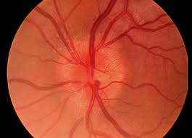

Spastic Paraparesis
- Paraparesis is the partial paralysis of the lower limbs
- Spastic paraparesis indicates an UMN affecting both legs; scissoring gait, UMN signs (hypertonicity, hyperreflexia, upgoing plantar reflexes, clonus)
- Causes:
Childhood onset | Adult onset
- Neurological → cerebral palsy  - Structural → Chiari malformations  - Hereditary  - Infection → myelitis | - Structural → C-spine degeneration  - Neurological → MND, MS  - Malignancy → primary or secondary  - Metabolic → B12 or vitamin E  - Infection → syphilis, HIV

Natural History and Prognosis
- Relapsing-Remitting (80%)
- Secondary progressive (10%)
- Primary progressive (10%) – often present later in life with spastic paraparesis
- Progressive relapsing (rare) 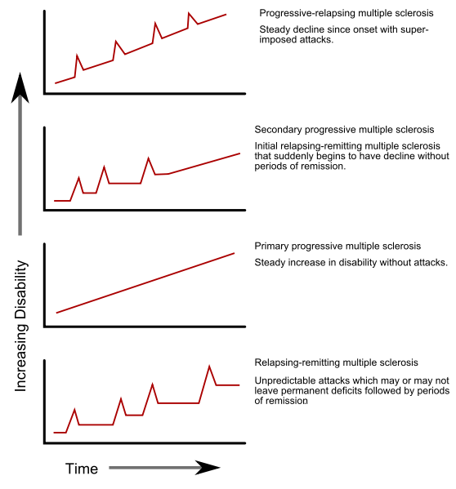
- Motor & cerebellar signs are associated with poor prognosis
- Most patients will survive 25 years from the onset of the disease (progressive subtypes
- Patients with advanced MS will often suffer from
  - Optic atrophy and nystagmus
  - Cerebella dysarthria
  - Ataxia
  - Urinary incontinence
  - Spastic paraparesis
  - Dementia
  - Pressure sores
- Neurorehabilitation aims to restore the patient to maximum capability and independence within the limits set by their disability and needs
  - Integrated Neurological Services (INS) is a registered charity providing long term support for people with neurological conditions and their carers
  - Regular groups MS, PD, Stroke
  - Befriending services etc.
Stretch Reflex
- Spindle fibres (intrafusal) have a non-contractile position
- Compares desired muscle length to actual length
- If muscle is shortening too slowly, spindle fibre afferents are activated to increase alpha MN input (via a reflex)
- Tendon hammer artificially induces spindle fibres afferents causing increased alpha MN output via a reflex
- Modulated by descending control in UMN lesions reflexes are increased because of this loss
