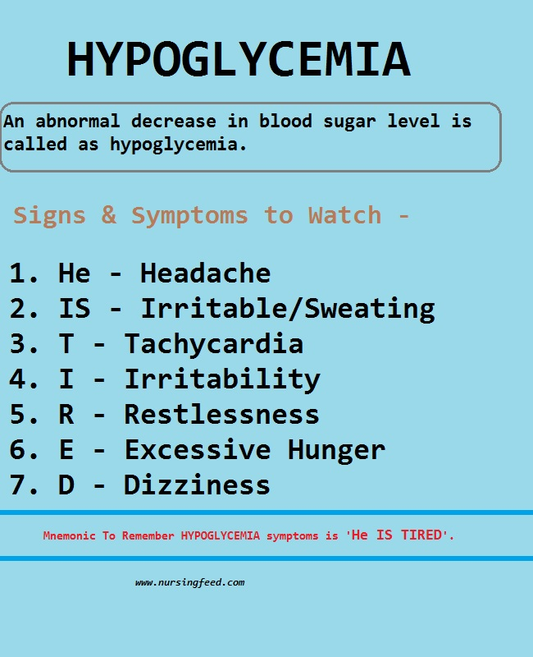
Causes
- Insulin or sulphonylurea treatment in a known diabetic e.g. with activity, missed meal, accidental or non-accidental overdose
- Insulinoma
  - Often benign (90 – 95%) pancreatic islet cell tumour is sporadic or seen with MEN 1
    - MEN 1: 3 Ps: Parathyroid, Pituitary, Pancreas (insulinoma/gastrinoma)
  - Presents as a fasting hypoglycaemia with Whipple’s Triad
  - Suppressive tests: Give IV insulin and measure C peptide
    - Fails to suppress insulin
  - Imaging: CT/MRI +/- Pancreatic US +/- Intraoperative visualization/US
In non-diabetic Adults you must EXPLAIN the mechanism
- Exogenous drugs
  - Insulin
  - Oral hypoglycaemic
  - Body builders may misuse insulin to help stamina
  - Alcohol – binge with no food (inhibition of gluconeogenesis)
  - Aspirin poisoning
  - ACE inhibitors
  - B blockers
  - Pentamidine
  - Quinine sulphate
  - Aminogluthamide
  - Insulin like growth factor
- Pituitary insufficiency
  - Growth hormone deficiency
- Liver failure
- Addisons disease (adrenal insufficiency)
- Islet cell tumours (insulinoma) and immune hypoglycaemia i.e. seen in Hodgkins disease
- Non pancreatic neoplasms e.g. fibrosarcomas and haemangiopericytomas
  - In children nesidoblastosis – beta cell hyperplasia

Symptoms and Signs
- Plasma <3mmol/L
- Whipple’s Triad (True Hypoglycaemia)
  - SYMPTOMS + LOW GLUCOSE + RESOLUTION AFTER INC. SUGAR
- Autonomic symptoms: result of an increased secretion of glucagon, adrenaline, cortisol and growth hormone in an effort to elevate blood sugar levels
  - Sweating
  - Anxiety
  - Hunger
  - Tremor
  - Palpitations
  - Dizziness
- Neuroglycopenic symptoms result from insufficient glucose supply to brain despite the sympathoadrenal attempts to raise blood sugar
  - Confusion
  - Drowsiness
  - Visual trouble
  - Seizures
  - Coma
  - Rarely focal symptoms e.g. transient hemiplegia, mutism, personality change, restlessness and incoherence
- These symptoms may lead to the misdiagnosis of alcohol intoxication or even psychosis

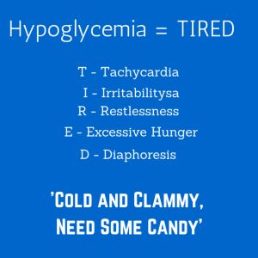

Treatment
15 – 20g of fast acting glucose (if co-operative) + Long acting starch e.g. Toast
100ml of 10% Glucose IV via large vein with 0.9% saline flush (to prevent phlebitis)
Check glucose every 15 minutes
Glucagon 1mg IM if no IV access (short term effect)
If episodes are often, advise many small high starch meals
If post prandial low glucose, give slowly absorbed carbohydrate (high fibre)

