6th Nerve Palsy
- Cranial nerve 6 has a long intracranial course that can be damaged in the brainstem (e.g. by MS or infarction)
- In raised intracranial pressure, it is compressed against the tip of the petrous temporal bone
- Nerve can also be infiltrated by tumours
- Signs
  - Horizontal diplopia on looking out (side by side) – maximal when looking to the side of the lesion
  - Inward eye deviation in the primary position
- Causes
  - Sensory: trigeminal neuralgia (pain but no sensory loss), herpes zoster, nasopharyngeal cancer, acoustic neuroma
  - MS
  - Wernicke’s encephalopathy
  - False localising sign in increased ICP
    - Spinal cord lesions also cause false localising signs
  - Pontine stroke (small fixed pupils and quadriparesis)

- Internuclear Ophthalmoplegia
  - To produce synchronous eye movements, cranial nerves 3, 4 and 6 communicate through medial longitudinal fasciculus in the midbrain
  - In INO, a lesion disrupts communication causing weakness in adduction of the IPSILATERAL eye with NYSTAGMUS of the contralateral eye when ABDUCTING
  - There may be incomplete or slow abduction of the ipsilateral eye during lateral gaze
  - Convergence is preserved
  - Cranial nerve 6 has a long intracranial course, it can be damaged in the brainstem e.g. by MS or infarction
3rd Nerve Palsy

- Occulomotor nerve supplies superior rectus, inferior rectus, medial rectus and inferior oblique, Levator palperbrae superiosris and parasympathetic constriction of the pupil
- Signs
  - PTOSIS (unilateral complete)
  - LARGE PUPIL unreactive to light or accommodation (think of a dying person)
  - EYE DOWN & OUT (due to unopposed lateral rectus and superior oblique)
- Signs of partial nerve palsy
  - Often associated with the development of binocular vision
  - Patients do not complain of diplopia as ptosis covers the eye
  - Sparing of the pupil indicates parasympathetic fibres are undamaged
  - Diabetic 3rd nerve infarction is usually painless and pupil sparing unlike compression by a posterior communicating artery aneurysm
- Causes
  - Medical
    - Diabetes
    - Hypertension
    - Giant Cell Arteritis
    - Syphillis
    - Idiopathic
  - Surgical
    - Posterior communicating artery aneurysm (+surgery)
    - Increased ICP
      - i.e. Uncal herniation through the tentorium compresses the nerve

Snellen Chart
- 6/6 = Normal vision
  - a patient can read a line of symbols at 6m what a person with normal visual acuity would be able to read at 6m
- 6/60 = POOR vision
  - They are able to read at 6m what a person with normal vision can read at 60m
- 6/5 = GREAT vision
  - They are able to read at 6m what a person with normal visual acuity can only read at 5m

Horner’s Syndrome
- Features (PEAS):
  - Ptosis
  - Enophthalmos (sunken eye)
  - Anhidrosis (loss of sweating one side)
  - Miosis (Small pupil)
- Distinguishing between different causes
  - Heterochromia (difference in eye colour) is seen in congenital Horner’s
  - Anhidrosis



5th Nerve Palsy
- Cranial nerve 5 is the largest cranial nerve: mainly sensory with a motor component to the muscles of mastication
  - Some Say Money Matters But My Brother Says Big Brains Matter More
- 3 divisions: V1 (Ophthalamic), V2 (Maxillary), V3 (Mandibular)
- Ascending fibres transmitting light touch enter the 5th nucleus in the pons
- Pain and temperature fibres also end in 5th nucleus
- Sensory aspect allows Corneal Reflex
- Causes: trigeminal neuralgia, herpes zoster, nasopharyngeal cancer, acoustic neuroma
- Symptoms and Signs of a 5th Nerve lesion
  - Reduced sensation in the 3 regions (light touch, pain, cold)
  - Reduced masseter function and pterygoids
    - When the patient opens their mouth, their jaw deviates to the side of the lesion
  - Absent corneal reflex
- Wallenberg Syndrome
  - Stroke causes loss of pain-temperature sensation from one side of the face and the other side of the body

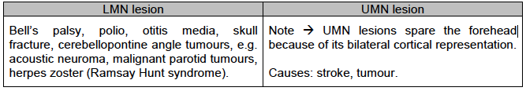
7th Nerve Palsy
- Neurones in EACH 7TH NUCLEUS supplying the upper face (principally frontalis) receive bilateral supranuclear innervation
- Facial nerve lesions cause droop and weakness – as the forhead has bilateral representation in the brain, only the lower2/3 is affected in UMN Lesions , but all of one side of the face in LMN lesions
- In UMN , there is sometimes preservation of spontaneous emotional movement (e.g. smiling) compared with voluntary movement

Bulbar Palsy (LMN)
- Impairment of CN 9,10, 11 and 12 due to a LMN lesion at either nuclear or fascicular level in the medulla oblongata or from lesions of the lower cranial nerves outside the brainstem
- Causes include: Kennedy’s disease, medullary infarction, ALS (MND), Syringobulbia, GBS, poliomyelitis, lime disease, brain stem glioma, botulism, Myaesthenia gravis
- Dysphagia, Difficulty in chewing, nasal regurgitation, slurring of speech, choking on liquids, dysphonia (defective use of the voice), dysarthria, dysphasia

Trigeminal Neuralgia
- SEVERE UNILATERAL PAIN
  - Brief electric shock like pains – abrupt in onset and termination
  - Limited to one or more divisions of the trigeminal nerve
  - Pain evoked by light touch e.g. washing, shaving, smoking, talking and brushing the teeth (trigger factors) and frequently occurs spontaneously
  - Small areas in the nasolabial fold or chin may be particularly susceptible to the precipitation of pain (trigger areas)
  - The pains usually remit for variable periods
- Majority of cases are idiopathic but compression of the trigeminal roots by tumours or vascular problems may occur
  - Younger patients are more likely to have MS or CPA tumours
- Hypertension is the main risk factor
- Carbamazepine is 1st line treatment
  - Failure to respond / atypical features (e.g. <50yrs) = prompt referral to neurology
Visual Pathways
- Parasympathetic – Acetylcholine CONSTRICTION + ACCOMODATION (Near Vison)
  - Short ciliary nerves = short distance
- Sympathetic (Noradrenaline) acting on a1 DILATION
  - Long ciliary nerves = long distance
- Light Reflex (Direct and Consensual)
  - Light Retinal ganglion cell Pretectal nucleus (distributor) Edinger westphal nucleus Cranial nerve III Ciliary ganglion Sphincter pupillae
- REMEMBER
  - EACH CORTICAL HEMISPHERE DEALS WITH THE VISUAL CONTRALATERAL HALF OF THE WORLD
    - THEREFORE, IPSILATERAL HALF OF EACH RETINA
  - Blind spot is about 15 degrees laterally from looking straight
- In front of the optic chiasm different deficits in the two eyes
- Behind the optic chiasm matching deficits in both eyes
- BITEMPORAL HEMIANOPIA
  - Lesion of optic chiasm
    - Upper Quadrant > Lower Quadrant defect = inferior chiasmal compression i.e. pituitary tumour
    - Lower quadrant defect > upper quadrant defect = superior chiasmal compression i.e. craniopharyngioma (cranio goes low)
- ROUGH LOSS OF PERIPHERAL VISION IN EACH EYE – tunnel vision
  - Bilateral Retinal Damage – Glaucoma
  - Raised intraocular pressure (usually)
  - Initially decreased axons from peripheral retina
- UNMATCHED CENTRAL SCOTOMA
  - Disease of the macula – AMD
  - Loss of central photoreceptors
- UNILATERAL SCOTOMA
  - E.g. tumour detachment, infection
  - Defect depends on location of lesion

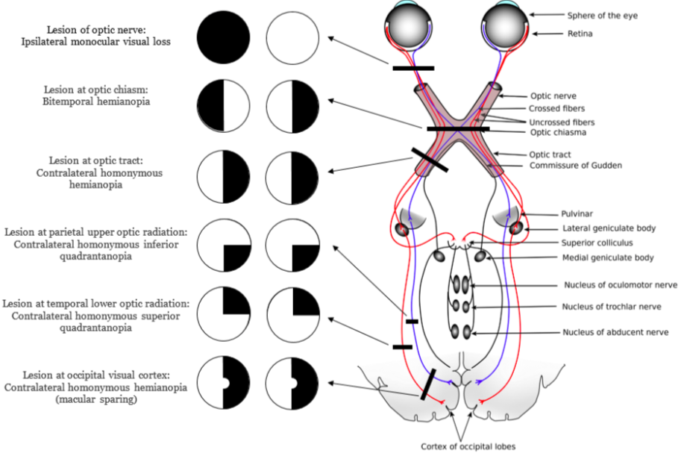
Pseudobulbar Palsy (UMN)
- Result of damage to the UMN (corticobulbar tract)
- Causes include: Progressive supranuclear palsy, ALS, Parkinsons, MS, Behcet’s disease
- Slow and indistinct speech, dysphagia, small stiff and spastic tongue, brisk jaw jerk, dysarthria, labile affect (crying), gag reflex may be normal exaggerated or absent
Visual Physiology
- Unlike normal cells, when light shines on the cone cells, Na+ channel is blocked and K+ HYPERPOLARISATION DECREASED GLUTAMATE
- Active photopigment cis trans +opsin
- Conjugate eye movements saccadic
- Retinal + lateral geniculate nucleus : Contrast + Wavelength
- Primary visual cortical cells: Corners + orientation + motion + binocular disparity (gain idea of depth)
- Disconjugate movements
  - I.e. convergence

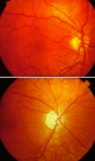
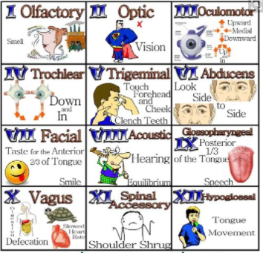
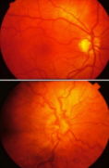
Aspiration Risk
- Coughing
- Wet hoarse voice
- Reduced conscious level
- WATER SWALLOW TEST
  - Initially with a teaspoon
Optic Atrophy
- Pale, well demarcated disc on fundoscopy
- Usually bilateral and causes a gradual loss of
vision
- Acquired Causes
  - Multiple sclerosis
  - Papilloedema (long standing)
  - Raised intra-ocular pressure (glaucoma,
tumour)
  - Retinal damage (choroiditis, retinitis
pigmentosa)
  - Ischaemia
  - Toxins: tobacco amblyopia, quinine, methanol, arsenic, lead
  - Nutritional: vitamin B1, B2, B6 and B12 deficiency
- Congenital Causes
  - Friedreich’s ataxia
  - Mitochondrial disorders e.g. Leber’s optic atrophy
  - DIDMOAD: the association of cranial diabetes insipidus, diabetes mellitus, optic atrophy and deafness (Wolfram’s syndrome)

Anatomy - Clinically Relevant Points
- Olive nucleus
  - Lateral Olivary Nucleus; LOUDNESS/HIGH PITCH
  - Medial Olivary Nucleus; TUNING/ LOW PITCH
  - Inferior Olivary Nucleus; CORRECTION OF EYE
- Midline Brainstem Structures O’TAH= Somatic Motor Nuclei
  - Occulomotor // Trochlear // Abducens // Hypoglossal
- Visceral Motor Nuclei
  - Parasympathetic: CN 3, 7, 9 and 10
    - Edinger Westphal, Superior and inferior salivary nuclei, dorsal motor nucleus of vacus
- Branchiomotor: Trigeminal, Facial, Nucleus Ambiguus (9,10, 11)
Cavernous Sinus:Contains: 3, 4, 5, 5, 6 – compressed if there is coronary artery aneurysm
Base of skull
- V1 comes out the Superior orbital fissure
- V2 comes out of the Foramen Rotundum
- V3 comes out of the Foramen Ovale
- Facial Nerve: also passes through the auditory meatus in the base of the skull (along with the vestibulocochlear nerve)
  - Tell Ziggy Bob Marley Called; Temporal, Zygomatic, Buccal, Mandibular, Cervical
  - Exits through the Stylomastoid Foramen
  - Motor root BRANCHES WITHIN PAROTID SALIVARY GLAND
  - Facial nerve also is responsible for the parasympathetic lacrimal and saliva glands
- BELLS PALSY
  - Hemifacial weakness (no forehead sparing unlike in UMN), corneal ulceration, hyperacusis, dygeuesia, aberrant reinnervation i.e. smiling = crying; treated with Prednisolone 1mg/kg for 10 days prescribed within 72 hours of onset + Artificial Tears
  - Other causes of Facial nerve palsy
    - Lyme disease Borrelia sp, Ramsay hunt syndrome
    - Latent varicella zoster virus reactivation
    - Meningitis e.g. fungal, viruses: HIV, Polio, mycoplasma, TB
    - MS, Stroke, Tumour, Acoustic Neuroma, Meningioma, DM, Sarcoidosis, DM, Guillian Barre Syndrome (usually bilateral palsy)
    - Orofacial granulomatosis, parotid tumours, cholesteatoma, otitis media, trauma to skull base, diving (barotrauma + temporal bone pneumoceole), intracranial hypertension
- Glossopharyngeal nerve
  - as well as what image displays, also sensory innervation to the carotid body and sinus + parotid salivary gland
  - MOTOR = STYLOPHARYNGEUS
- Vagus Nerve
  - Gag reflex efferent limb
  - Sensory external ear, aortic body and arch, some taste fibres
- Accessory nerve
  - Spinal accessory: sternocleidomastoid and trapezius
  - Cranial accessory: supplies larynx and pharynx
- Hypoglossal Nerve
  - All tongue muscles apart from palatoglossus
Superior cerebellar peduncle: the only outflow to the cerebrum

Drugs That Cause Pupillary Dilation
- Topical Mydriatics
  - Atropine
    - Blocks acetylcholine
  - Phenylephrine
  - Tropicamide
    - Sympathomimetic
  - Cyclopentolate
    - Muscarinic antagonist
- Sympathomimetics
  - Amphetamine
  - Cocaine
- Anticholinergic drugs
  - Tricyclic antidepressants

Papilloedema
- Swelling of the optic disc
- Causes
  - Raised intracranial pressure
  - Brain tumour, abscess, haemorrhage
  - Idiopathic intracranial hypertension
  - Hydrocephalus
  - Venous occlusion (focal neurological deficits)
  - Venous sinus thrombosis
  - Optic nerve disease
  - Optic neuritis e.g. Multiple sclerosis
  - Ischaemic optic neuropathy e.g. Giant Cell Arteritis
  - Toxic optic neuropathy e.g. methanol
  - Central retinal vein thrombosis
  - Orbital mass lesions
  - Retinal vascular disease
  - Malignant hypertension (accelerated phase)
  - Leukaemia ALL
  - Sarcoidosis
  - Optic nerve glioma
  - Vasculitis e.g. SLE
  - Hyperammonaemia
  - Hypervitaminosis A
  - Respiratory failure
  - Hypocalcaemia
  - Disc infiltration
  - Any CNS infection if prolonged (e.g. TB, Meningitis

